COVER PAGE

Title: The scaling of swimming speed

Author: James Richard Usherwood.
Orcid ID: 0000-0001-8794-4677
Structure and Motion Lab.,
The Royal Veterinary College,
North Mymms,
Hatfield,
Herts
AL9 7TA

Key words: Swim, fish, whale, work, power, speed
The scaling of maximum swimming speed

Dear Editor,
Maximum speed swimming can be assumed to be under strong selective pressure: faster predators can catch fast prey; faster prey can avoid fast predators. Maximum speeds are presumably bounded by physical and physiological constraints. Here, I consider these in the context of scaling (Figure 1) and compare predictions with conservative reported values (Figure 2); see Sánchez-Rodríguez et al., (2023) for a fuller data set and discussion of their varied merits and issues. The true relationship between animal length and maximum swimming speed is unclear because studies over a large size range demand disparate measurement techniques and animals with very different motivations. However, it appears safe to assume that neither a single extrapolation of 10 body lengths/second can apply to large animals, nor a constant top speed be applied to smaller fish: a 30m blue whale surely cannot reach 300m/s, and a 5cm goldfish cannot swim at 10m/s.
The approach here is to focus on the fundamentals of demand and supply: it assumes that mechanical power is demanded to overcome body drag, and this must be supplied by muscle which is limited in its capacity to generate either power during, or work over, a contraction. An important constraint of locomoting animals is that each muscle can be contracted usefully only once each cycle. This constraint is trivially circumvented with machines: modern bicycles, unlike the Penny Farthing, allow one pedal stroke for many turns of the wheel; a winch allows many turns of the crank for one turn of the spool. The issue of a 1 : 1 contraction : gait cycle ratio, and the implications of contrasting constraints of muscle work and power, have been explored in relation to bird flight (Usherwood, 2016) and top speeds of running animals (Usherwood and Gladman, 2020). The same muscle constraints are applied here assuming that, at top swimming speed, propulsion is achieved at high efficiency; that is, for a given speed and power supply, thrust is maximised (Usherwood, 2026).
The scaling of fatigue (e.g. Wardle, 1977) has been proposed as an account for the limited top speeds of large animals (Hirt et al., 2007), as has activation/deactivation timing, (Wardle, 1975), and muscle properties and internal moment arms (Sánchez-Rodríguez et al., 2023). Issues with producing net mechanical power at low contraction frequencies were highlighted by Hill (1950), and is supported by recent observation of breaching animals (Halsey and Iosilevskii, 2020). However, the current prevailing account – at least for larger fish, dolphins and whales – appears to be the avoidance of cavitation (Iosilevskii and Weihs, 2008). This is considered here in the context of scaling using very basic principles; the detailed work of Iosilevskii and Weihs (2008) should take precedence.
Model scaling relationships are plotted (Figure 2) assuming a swimmer of body length 1m can achieve 10m/s; a convenient point that is approximately consistent with the reliable data (see Figure 2 key for references). While considerably higher speeds can be found in the literature, for instance dolphin at 15m/s (Lockyer and Morris, 1987), and tuna and wahoo at 21 m/s (Walters and Fierstine, 1964), these values tend to be dismissed on methodological grounds (Fish and Rohr, 1999; Sánchez-Rodríguez et al., (2023)). The blue whale data point (Gawn, 1948) is included despite lack of methodological detail, and should be viewed with some caution.

- Scaling of power demand
Assuming body shape to be geometrically similar (presumably a streamlined, low-drag form), body drag D is proportional to the body area S_{body} (Figure 1) and the square of forward velocity V (though see also Discussion):

$D∝S_{\text{body}}V^{2}∝L^{2} V^{2}$; (1)

and the power demanded to provide the thrust to overcome body drag is proportional to the cube of velocity:

$P_{\text{demand}}∝D V ∝L^{2} V^{3}$. (2)

- Muscle power supply constraint
If the maximum power supply is limited by a mass-specific muscle power capacity $P^{*}$ that does not scale, then

$P_{\text{supply,P}}∝L^{3}$. (3)

At the limiting velocity $V_{\text{max,P}}$ when $P_{\text{demand}}=P_{\text{supply,P}}$, from (2) and (3)
$L^{2} V_{\text{max,P}}^{3}∝L^{3}$; (4)
$V_{\text{max,P}}∝L^{\frac{1}{3}}$. (5)

- Muscle work supply constraint
The same mean power demand must be provided with muscles that contract to perform work. Thus the work-constrained power supply $P_{\text{supply,W}}$ available from the muscle depends on the mass specific work capacity for the muscle W* – assumed here to not scale with size – and the tailbeat frequency f:

$P_{\text{supply,W}}∝L^{3}f$. (6)

In order to operate as an efficient propulsor, frequency relates to both velocity and tailbeat amplitude A. The principles underlying this is explainable with classic propeller theory (Usherwood, 2025, 2026), and the phenomenon is consistent with the observation of a broadly consistent ‘Strouhal number’ (=Af/V) in cruising swimmers (Triantafyllou et al., 1993; Triantafyllou et al., 2000; see also Rohr and Fish, 2004 and references therein). For high efficiency:

$Af∝V$. (7)

Assuming the tailbeat amplitude to be a constant proportion of body length at maximum speed (see Bainbridge, 1958), combining (6) and (7) provides:

$P_{\text{supply,W}}∝L^{2} V$. (8)

At the limiting velocity $V_{\text{max,W}}$ when $P_{\text{demand}}=P_{\text{supply,W}}$:

$L^{2} V_{\text{max,W}}^{3}∝L^{2} V_{\text{max,W}}$ (9)

so

$V_{\text{max,W}}∝L^{0}$. (10)

- Transition between muscle power and work constraints
The proposition is that, from expressions (5) and (10), and as shown on Figure 2, at small scales, mean power supply depends on the power capacity of the muscle, whereas at large scales, muscle power supply scales with tailbeat frequency as the muscle can produce only so much mechanical work each contraction. Is the transition between ‘small’ and ‘large’ scales, taken to be at L=1 m, V=10 m/s to match the inflection in reported top speeds, broadly consistent with physiological and hydrodynamic considerations? The contraction duration t_{c} at the transition between the two regimes can be predicted given muscle properties W* and P*; at this transition the mean power capacity is equally constrained by both factors:

$P^{*}=\frac{W^{*}}{t_{\text{c}}}$. (11)

If powering muscle contracts over half the tailbeat period, then the transition from power-limited to work-limited conditions would occur at:

$f=\frac{P^{*}}{2 W^{*}}$. (12)

Suitable values for P* and W* are difficult to determine, even for a given muscle, as they depend on contraction conditions: brief contractions with high muscle strain rates are required for high P*, but long duration contractions allow high muscle stress and enable higher W*. This interplay is explored a little in Usherwood, 2024. However, for the purposes of a very approximate – best viewed as an order-of-magnitude – estimate, if P*=150 W/kg (e.g. Wakeling and Johnston, 1998) and f=10Hz (see Sánchez-Rodríguez et al., 2023), this would mean t_{c}=0.05s, indicating W*=7.5 J/kg. Is this a reasonable value? It would equate to a quarter of the maximum isometric stress (approximately 150 kPa; Wakeling and Johnston, 1998) over a strain of 20%; both reasonable for a contracting muscle. If the tailbeat amplitude A was 0.2 body lengths (an observation conserved across speeds and sizes for small fish (Bainbridge, 1958) and small to medium whales (Rohr and Fish, 2004)), a swimming speed of 10m/s would result in a Strouhal number ranging between 0.2 to 0.4, approximately the range observed among cruising swimmers and thought to result in high hydrodynamic efficiency, for body lengths of 1-2m. The transition between power- and work- constrained maximum speed is not expected to be quite as sudden as indicated because of the compromising interplay between maximum power and work capacity for a contraction, even for a given muscle.

- Cavitation
Cavitation occurs when local pressure falls below water vapor pressure: if a part of a foil experiences a sufficiently low pressure, the water changes state from liquid to gas. This is usually viewed as detrimental for propellers: it tends to be noisy and damaging as the gas collapses back to liquid as the pressure returns towards ambient beyond the foil, and it would presumably be damaging and/or painful to an animal. The generation of thrust requires a net difference in pressures between the forward and rear surfaces: the forward surface under largely negative or ‘suction’ pressure, and the rear surface positive (with respect to ambient). Here, the demand for an average pressure difference p comes from the requirement for sufficient thrust T from the propulsive foil of area S_{foil} to overcome body drag (1):

${T ∝p S}_{\text{foil}}{∝(-)D ∝S}_{\text{body}}V^{2}$. (13)

If the the limiting local pressure p_{lim} at maximum cavitation-limited speed V_{max,cav} is a constant multiple of the mean pressure difference across the foil (the relative pressure distribution around the foil is constant, but the magnitude is dependent on the thrust), and assuming geometric similarity of both body and foil,

$p_{\text{lim}} L^{2}∝ L^{2} V_{\text{max,cav}}^{2}$; (14)

$V_{\text{max,cav}}∝L^{0}$. (15)

This derivation is consistent with the more comprehensive analysis by Iosilevskii and Weihs (2008) which additionally asserts that the pressure limit is of suitable magnitude to be a potential limiter of speed in large fish and dolphins. Note that this applies only to swimming at a given depth; greater depths would allow greater pressures before the water vapour pressure – and cavitation problems – were reached.

Discussion
At small scales, maximum fish speed appears to scale more strongly than predicted by the power constraint. The causes of this, whether due to issues with motivation or experimental detail, departure from the assumptions concerning demand (scaling of drag), or supply (muscle properties) fall beyond the scope of this letter. However, a semi-empirical modification of the drag model appropriate for small, slower swimming (low Reynolds numbers, laminar flow (from Hoerner, 1965)) indicates differences in flow regime might account for part of this discrepancy. In this case
$D_{\text{laminar}}∝S_{\text{body}}V^{2}\frac{1}{\sqrt{LV}}∝L^{\frac{3}{2}} V^{\frac{3}{2}}$; (16)
$P_{\text{laminar}}∝D_{\text{laminar}}V∝L^{\frac{3}{2}} V^{\frac{5}{2}}$, (17)
making the muscle-power maximum velocity prediction for laminar conditions
$V_{\text{max,P,laminar}}∝L^{\frac{3}{5}}$. (18)
For completeness, a further semi-empirical scaling adjustment applicable to fast, large swimmers (high Reynolds numbers, turbulent flow, discussed in Vogel, 1996, citing Hoerner, 1965) can be applied to the work-constraint model:
$D_{\text{turbulent}}∝S_{\text{body}}V^{2}{\left(LV\right)}^{\frac{-1}{5}}∝L^{\frac{9}{5}} V^{\frac{9}{5}}$; (19)
$P_{\text{turbulent}}∝D_{\text{turbulent}}V∝L^{\frac{9}{5}} V^{\frac{14}{5}}$, (20)
making the muscle work constrained maximum velocity prediction for turbulent conditions
$V_{\text{max,W,turbulent}}∝L^{\frac{1}{9}}$. (21)
The transition between the drag models, the sensitivity to surface detail, and the validity of the scaling exponents in other than rigid bodies, particularly swimming bodies (Webb, 1975), mean that both adjustments should be viewed with caution. Both are included in Figure 2. For reference, the Reynolds number at the proposed intersection of power- and work- constraints (L=1, V=10) would be approximately 10⁷ in water.
At intermediate scales – 0.2-2m – the simple power constraint model is consistent with observation. At larger scales – above 1m – reported maximum speeds appear approximately constant, consistent with the work constraint model, as – approximately – is the transition point between power- and work- constraints given realistic muscle properties. The cavitation limit model also predicts absence of scaling. Distinguishing between the two models predicting constant maximum speeds is not feasible here.
While this study provides one simple account for why the whale cannot hit 300 m/s, nor the goldfish 10 m/s, it does raise a number of questions: why do small fish appear quite so slow? Why are work constraints not ameliorated with relatively high frequency, low amplitude tailbeats at larger sizes? And why – if pressure and cavitation is limiting – do the fastest swimmers not have disproportionately high tail areas (though see Usherwood, 2026)? And which, between work and cavitation constraints, provides the better account for the apparent absence of scaling in top speed among large swimmers?

Acknowledgements
I am most grateful to two reviewers for their expert and thoughtful comments. This work was funded by my employment at The Royal Veterinary College.

Figures
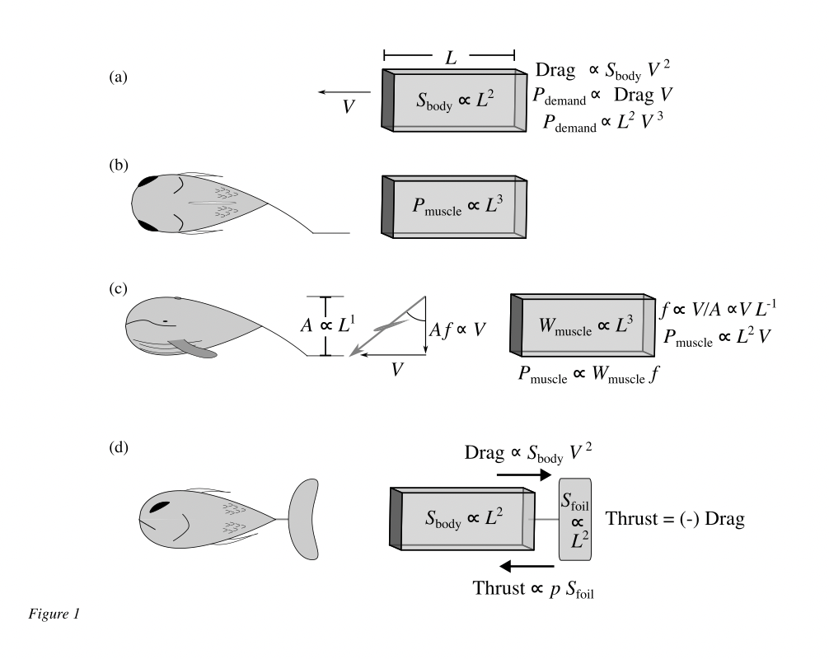
Figure 1.
Cartoons summarising the assumptions for the models of (a) power demand to overcome body drag, (b) muscle power supply, (c) muscle power supply for a work-limited muscle operating with tailbeat frequency required for high hydrodynamic efficiency, and (d) the demand of pressure to provide thrust to overcome drag, potentially resulting in a speed limit before cavitation. See text for fuller development.

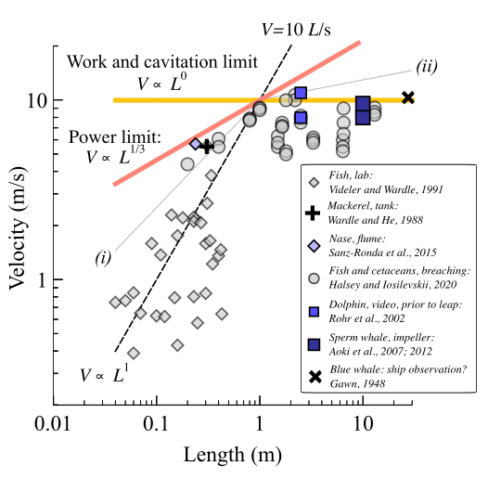
Figure 2.
Data (points, see figure key for sources) and scaling predictions (solid lines) and approximate fit to a variety of empirical data (dashed line) for maximum swimming speeds for a range of body lengths. Note the logarithmic transformation of the axis marker spacing. Scaling lines intercept at L=1m, V=10m/s. Classic semi-empirical adjustments are shown for laminar flow ((i), more suitable for smaller scales and lower speeds), and for turbulent conditions ((ii), more suitable for larger scales and higher speeds). Maximum observed speeds for small fish fall somewhat below predictions for the muscle power limit; intermediate fish fall close to the power limit models; large fish, dolphin and whale maximum speeds scale little with size, consistent with both the constrained muscle work and cavitation avoidance predictions.

List of symbols

Symbol | Meaning
A | Tailbeat amplitude
D | Body drag
f | Tailbeat frequency
L | Length
P | Power
p | Pressure
S | Area
T | Thrust
t | Time
V | Forward velocity
Symbols, subscripts
body | Body
cav | Cavitation
c | Muscle contraction
demand | Demand on muscle
foil | Foil: fin or fluke
laminar | Laminar (relevant to small scale, slow flows)
m | Muscle
max | Maximum
supply | Supply from muscle
turbulent | Turbulent (relevant to large scale, fast flows)
P | Power
W | Work
Symbols, superscripts
* | Mass specific

References
Aoki, K., Amano, M., Mori, K., Kourogi, A., Kubodera, T. and Miyazaki, N. (2012). Active hunting by deep-diving sperm whales: 3D dive profiles and maneuvers during bursts of speed. Mar. Ecol. Prog. Ser. 444, 289-301. doi:10.3354/meps09371

Aoki, K., Amano, M., Sugiyama, N., Muramoto, H., Suzuki, M., Yoshioka, M., Mori, K., Tokuda, D. and Miyazaki, N., (2007). Measurement of swimming speed in sperm whales. In 2007 Symposium on Underwater Technology and Workshop on Scientific Use of Submarine Cables and Related Technologies (pp. 467-471). IEEE.

Bainbridge, R. (1958). The speed of swimming of fish as related to size and to the frequency and amplitude of the tail beat. Journal of experimental biology, 35(1), 109-133.

Fish, F. E. and Rohr, J. (1999). Review of dolphin hydrodynamics and swimming performance SPAWARS System Center Technical Report 1801 (San Diego CA). https://apps.dtic.mil/sti/tr/pdf/ADA369158.pdf

Gawn, R.W.L. (1948). Aspects of the locomotion of whales. Nature 161, 44-46.

Halsey, L.G. and Iosilevskii, G. (2020). The energetics of ‘airtime’: estimating swim power from breaching behaviour in fishes and cetaceans. J. Exp. Biol. 223. doi:10.1242/jeb.216036.

Hill, A. V. (1950). The dimensions of animals and their muscular dynamics. Science Progress (1933-), 38(150), 209-230.

Hirt, M.R., Jetz, W., Rall, B.C. & Brose, U. (2017). A general scaling law reveals why the largest animals are not the fastest. Nat Ecol Evol 1, 1116-1122. (doi:10.1038/s41559-017-0241-4).

Hoerner, S.R. (1965). Fluid-dynamic drag. Hoerner fluid dynamics, Brick Town, NJ.

Iosilevskii, G., & Weihs, D. (2008). Speed limits on swimming of fishes and cetaceans. Journal of the Royal Society Interface, 5(20), 329-338.

Lockyer, C., & Morris, R. (1987). Observations on diving behaviour and swimming speeds in a wild juvenile Tursiops truncatus. aquat mamm, 13(1), 31-35.

Rohr, J. J., & Fish, F. E. (2004). Strouhal numbers and optimization of swimming by odontocete cetaceans. Journal of Experimental Biology, 207(10), 1633-1642.

Rohr, J.J., Fish, F.E., Gilpatrick, J.W. (2002). Maximum swim speeds of captive and free-ranging delphinids: critical analysis of extraordinary performance. Marine mammal science 18, 1-19.

Sánchez-Rodríguez, J., Raufaste, C., & Argentina, M. (2023). Scaling the tail beat frequency and swimming speed in underwater undulatory swimming. Nature Communications, 14(1), 5569.

Sanz-Ronda, F. J., Ruiz-Legazpi, J., Bravo-Córdoba, F. J., Makrakis, S., & Castro-Santos, T. (2015). Sprinting performance of two Iberian fish: Luciobarbus bocagei and Pseudochondrostoma duriense in an open channel flume. Ecological Engineering, 83, 61-70.

Triantafyllou, G.S., Triantafyllou, M.S. and Grosenbaugh, M.A. (1993). Optimal thrust development in oscillating foils with application to fish propulsion. J. Fluids and Structures. 7, 205-224.

Triantafyllou, M.S., Triantafyllou, G.S. and Yue, D.K.P. (2000). Hydrodynamics of fishlike swimming. Annu. Rev. Fluid Mech. 32, 33-35.

Usherwood, J.R. (2016). Physiological, aerodynamic and geometric constraints of flapping account for bird gaits, and bounding and flap-gliding flight strategies. Journal of Theoretical Biology 408, 42-52. (doi:10.1016/j.jtbi.2016.07.003).

Usherwood, J. R. (2024). The functions of leg muscles, structures and mechanisms in running. Biology Letters, 20(8).

Usherwood, J. R. (2025). Limiting and optimal Strouhal numbers or tip speed ratios for cruising propulsion by fins, flukes, wings and propellers. Journal of the Royal Society Interface, 22(222), 20240730.

Usherwood, J.R. (2026). Propeller efficiency and the spectrum of propulsor form with speed, from pike to tuna, vulture to swift. J. R. Soc. Interface doi: 10.1098/rsif.2025.0914

Usherwood, J. R., & Gladman, N. W. (2020). Why are the fastest runners of intermediate size? Contrasting scaling of mechanical demands and muscle supply of work and power. Biology Letters, 16(10), 20200579.

Videler, J. J., & Wardle, C. S. (1991). Fish swimming stride by stride: speed limits and endurance. Reviews in Fish Biology and Fisheries, 1(1), 23-40.

Vogel, S. (1996). Life in moving fluids: the physical biology of flow. Princeton university press.

Wakeling, J. M., & Johnston, I. A. (1998). Muscle power output limits fast-start performance in fish. Journal of Experimental Biology, 201(10), 1505-1526.

Walters, V., & Fierstine, H. L. (1964). Measurements of swimming speeds of yellowfin tuna and wahoo. Nature, 202(4928), 208.

Wardle, C. S. (1975). Limit of fish swimming speed. Nature 255, 757.

Wardle, C. S., & He, P. (1988). Burst swimming speeds of mackerel, Scomber scombrus L. Journal of fish Biology, 32(3), 471-478.

Wardle, C. S. (1977). Effects of size on the swimming speeds offish. In Scale Effects in Animal Locomotion. (T. J. Pedley, ed.), pp. 299–313. New York : Academic Press.

Webb, P.W. (1975). Hydrodynamics and energetics of fish propulsion. Bulletin of the Fisheries Research Board of Canada 190: 1-158.

