Title
A simple mechanical hypothesis for the diversity and speed-dependency of animal gaits

Author
TBC

ORCID ID
TBC

Address
TBC

Abstract

The basic mechanical work demands of supporting body weight with forces acting at ‘hips’ and ‘shoulders’ provides a simple account for the diversity of gaits observed in quadrupeds, and whether and how they change with speed. The favoured gait depends on the roll and pitch moments of inertia, the moment arms due to the body width and length, and the proportion of the stride cycle each leg supports weight (the duty factor). Trot avoids rolling and pitching, but imposes relatively large and costly vertical motions. The three even 4-beat gaits, tolt (running walk), transverse gallop and rotary gallop all reduce vertical motions, particularly important at the low duty factors associated with high speeds, but impose different roll and pitching motions, with contrasting energetic consequences. Body shape properties are predicted that explain why, with increasing speed: broad, long common hippopotamus trot but never gallop; upright giraffe transition directly from a walk to a rotary gallop and never trot; elephants tolt but never trot or gallop; horses trot and transverse gallop but do not rotary gallop; dogs trot, transverse and rotary gallop; and cheetah transition from trot to rotary gallop without the transverse gallop intermediate.

1. Introduction
1.1 Background
The functional implications of animal gaits, why different animals select different gaits, and why they transition with speed, have been of interest since at least the time of Aristotle (350 BCE). Prevailing accounts range from pseudo-static stability (e.g. Aristotle, 350BCE; Gray, 1944; McGhee and Frank, 1968; Jayes and Alexander, 1980; Cartmill et al., 2002) to spring-dominated (Blickhan, 1989, Geyer, 2006) or strut-dominated (Alexander 1976, 1977, 1989; Usherwood, 2005; Usherwood and Smith, 2018) dynamics to work-minimising principles (Alexander, 1984; Ruina et al., 2005; Srinivasan and Ruina, 2006) to display (e.g. Caro, 1986). The transition between walking and higher speed gaits appears broadly established: some combination of work minimisation and physical constraints (such as the inability legs to be loaded in tension or the feet to ‘pull’ up on the ground) applies to both bipeds (Alexander, 1989; Usherwood, 2005; Srinivasan and Ruina, 2006) and quadrupeds (Polet, 2021); though other kinematic (Hreljac, 1995) and force correlates may act as more proximate triggers. Attention here is given to the higher-speed quadrupedal gaits, specifically trot, tolt, transverse gallop and rotary gallop. Some gait transitions are reasonably consistent with metabolic energy minimisation (classically the walk-trot-gallop in horses; Hoyt and Taylor, 1981), though again other correlates may act as more proximate triggers (Farley and Taylor, 1991). But what drives this metabolic demand, and why does it vary differently with speed between gaits?
The long history of study into animal gaits has led to some conflicting descriptions and definitions. Here, the conventions of Hildebrand (e.g. 1989) are followed, and Hildebrand’s body of work quantifying gait characteristics should be recognised. The primary above-walking speed gaits and gait transitions are summarised in Table 1. The trot is familiar and widespread: it involves near-simultaneous contact of diagonal pairs of legs, and two non-pitching ‘bounces’ or vertical oscillations of the body each stride. While trot may be viewed as the default gait between walk and higher speed gaits such as galloping, it is noteworthy that some mammals walk at low speeds, gallop at higher speed but rarely or never trot at intermediate speeds (Giraffe: Selous, 1893; Gnu (wildebeest) and hyena, Pennycuick, 1976; many primates, Schmitt et al., 2006; raccoons, kinkajous and skunk, Van de Graaff et al., 1982 and McClearn, 1992). Further, the common hippopotamus appears never to transition out of a trot despite achieving high speeds (Hutchinson and Pringle, 2024). And elephants (and opossum) reach high speeds while not changing the limb phasing, (Hutchinson et al., 2006; White, 1990) adopting a running walk or ‘tolt’ but not trotting or galloping.
The transverse gallop is the normal high-speed gait of horses (e.g. Muybridge, 1957*), and intermediate-high speed gait of many dogs; whereas the rotary (formally rotatory) gallop is observed at all speeds above trot in cheetah, all speeds above walk in giraffe, and at the highest gallop speed in dogs. Despite considerable attention (Muybridge, 1957 [note to editor – not sure how to refence this appropriately; the source Muybridge is much earlier]; Gray, 1944), the implications of these two gallop gaits – or even clear-cut correlates with anatomy or behaviour – are not particularly secure. Of correlates, Muybridge offers “The transverse-gallop is employed by the horse, and by the greater number of other animals, both horny and soft-footed; the rotatory-gallop is adopted by the dog, the deer, and some other animals”, and Biancardi and Minetti (2012) present a large survey, finding: “Large size and longer proximal limb segments were associated with transverse gallop, while rotary and speed-dependent species showed higher metacarpus/humerus and metatarsus/femur length ratio and faster relative speeds”. Hildebrand (1980) speculates that rotary gallops might offer some advantage in terms of manoeuvrability. In species that adopt both transverse and rotary gallops, the transverse gallop is normally slower; rotary gallops may be associated with longer or different proportions of the stride unsupported in such species. While these unsupported periods and kinematic correlates have been proposed as indicating function, whether in terms of mechanical work reduction through altered centre of mass kinematics (Bertram and Gutmann, 2009) or elastic mechanisms (Alexander, 1988) this cannot offer a general account, as giraffes use a rotary gallop at all above-walking speeds and rarely have any unsupported phase. Further, there does not appear to be a mechanistic link between transverse/rotary footfall sequencing and either unsupported proportions or back flexion/extension.

1.1 Overview

Why do different species select different gaits? And why do the gaits selected sometimes, but not always, vary with speed (Table 1)? These questions are addressed with the assumption that – all other things being equal – gaits are selected that minimise mechanical work demand. Such a premise is not unusual; however, the assumptions made here contrast importantly with previous work. The Development begins with a summary and justification of the general assumptions, before describing three complementary work minimising models. The first relates to the energy demands of very brief, ‘impulsive’ forces, sometimes referred to as a ‘collisional’ analysis (see Ruina et al., 2005). The second presents theoretical possibilities for ‘zero-work’ extremes with finite duty factors. The purpose of these two is to allow the results of the third, numerical, model to be interpreted using mechanistic principles.

2. Development
2.0 Assumptions
2.0.0 General assumptions.
The main assumption for all three models is that gaits are selected that minimise the mechanical work demand of supporting the body during locomotion. This is clearly not the only cost of locomotion: energy is required to swing the legs (Fedak et al., 1982), and there may be a physiologically important cost of force (Kram and Taylor, 1990) or power (e.g. Usherwood, 2024) associated with muscle activation. However, given similar timing conditions for both swing and stance for a given speed, gait need not influence force demand or the time available to generate power, leaving the minimisation of work demand for body support to be a suitable objective function. Similarly, the role of elasticity should be acknowledged: some part of the mechanical work demands calculated here could be supplied by elastic recoil; however, assuming such recoil is not perfect, and assuming it not to relate to footfall sequencing and so gait, simple work minimisation is still relevant.

Unlike more reductive approaches that treat only the demands of supporting a centre of mass, (e.g. Ruina et al., 2005) or complex simulations that explore work and power demands of joints or muscles (e.g. van Bijlert et al., 2024), the fundamental demand assumed here is to support the four corners of the body with sufficient impulses or forces to support body weight. Only vertical forces and impulses are considered; this assumption is a key departure from previous studies, which tend to assume forces project either through the centre of mass, or through hip or shoulder joint centres (e.g. Alexander 1976, 1989). It is justified by the observation that ground reaction forces of a range of animals project well above – i.e. considerably more vertically – than through-hip or through-shoulder (Jayes and Alexander, 1978; Usherwood, 2020b; Usherwood, 2022). A range of mechanisms facilitating this without demanding simultaneous positive and negative muscle work has been described recently for hindlimbs and forelimbs of mammals (Usherwood, 2020b; Usherwood, 2022), though the possibility has long been recognised (Alexander, 1976). These vertical impulses or forces are assumed to act on a body of hip and shoulder width w, and hip-to-shoulder length L. The body is assumed to be rigid, allowing changes in roll and pitch to be calculated for given impulses or force profiles. This assumption is clearly extreme, and its validity depends not only on species (presumably a horse is closer to rigid-bodied than a cheetah) but also with speed (a trotting dog has markedly less back flexion/extension than a galloping dog). Despite these issues, it is a tractable starting point, adding one stage of complexity on top of point mass models; but it is admittedly a very long way from reality.

2.0.2 Moments of inertia and Murphy number
This study highlights the implications of roll and pitch for a body with roll and pitch moments of inertia I_{roll} and I_{pitch} respectively. A convenient non-dimensionalisation of the moment of inertia takes account of the moment arms of the weight-supporting impulses or forces about the centre of mass: for roll, with moment arm w/2:

${\hat{I}}_{roll}=\frac{I_{\text{roll}}}{4{mw}^{2}}$; (1)

and for pitch, with moment arm L/2:
${\hat{I}}_{pitch}=\frac{I_{\text{pitch}}}{4{mL}^{2}}$ (2)

This non-dimensionalisation is sometimes referred to as the ‘Murphy number’, acknowledging the contribution of Murphy (Lee and Biewener, 2011 and Polet, 2021, who cite Murphy’s thesis, Murphy, 1984), where a low Murphy number (<1) is shown to enable passively stable trotting in robots. More recently, the energetic implications have been recognised in pitch (Usherwood, 2019, Polet, 2021) or roll (Usherwood, 2019), but not previously in combination. A low Murphy number results in high rotational accelerations, and high energetic costs to gaits allowing rotational impulses. A high Murphy number results in low energetic costs due to rotations, resulting in gaits with low centre of mass work demands to be favoured, despite rotational impulses. An associated implication (Usherwood, 2019) is the acceleration experienced by the opposite side or end given a vertical impulse: an impulse accelerates the centre of mass upwards, but also accelerates rotation about the centre of mass; if $\hat{I}<1$, the combined effect is to accelerate the opposite side or end downward; if $\hat{I}>1$ it is accelerated upward.
A 60:40 bias in fore:hind weight distribution is generally reported for mammals. However, the bias for galloping horses (Self Davies et al., 2019), greyhounds and cheetah (Hudson et al., 2012) varies with speed, even reversing in high speed galloping, and the additional complexity due to including this parameter, and its interplay with pitch moment of inertia with associated energetic implications (Waldron et al., 2009) is not considered here.

2.0.3 Murphy number and shape
For a rectangle with side lengths a and b, and unit area ab, Aspect Ratio AR is defined as
$AR=\frac{a^{2}}{ab}$ (3)
so
$a=\sqrt{AR}$ (4)
And
$b=\frac{1}{\sqrt{AR}}$ (5)
The moment of inertia for a rectangular shape of mass m is given by

$I=\frac{m}{12}\left(a^{2}+b^{2}\right)$ (6)

So, for a rectangle of unit area

$I=\frac{m}{12}\left(AR+\frac{1}{AR}\right)$ (7)

meaning that upright (AR>1) or squat (AR<1) shapes have, for a given area, relatively high moments of inertia. Figures 1 and 3 show cartoons with bodies of constant area, with spans (leg width w or lengthwise spacing L) for a range of aspect ratios and $\hat{I}$.

2.0.4 Duty factor as function of speed
It is a general observation, at least for vertebrates above walking speeds, that duty factor $β$ – the proportion of the stride duration a given foot is in contact with the ground – goes down with increasing speed (see Alexander, 1984). A simple account for this is that, at frequencies sufficiently above those allowing gravitational pendular mechanisms to dominate swing timing, the energy demand of protracting the limbs forward may be considerable (Fedak et al., 1982; Hildebrand and Hurley, 1985). Elastic mechanisms (e.g. Wilson et al., 2003) and the potential for transfer between various ‘internal’ and ‘external’ energies, mean protraction costs may not be simply additive, making a formal inclusion of the implications of protraction energetics beyond the scope of this paper. However, consider the case of an animal running across a range of speeds with a constant duty factor. Given a limiting stance length (distance travelled over the period of a single limb ground contact), this would result in a constant stride length; and velocity would vary in proportion to stride frequency; and the kinetic energy to be supplied to swing the leg forward proportional to frequency – and so running velocity – squared. This increase in mechanical work demand with speed can be ameliorated by reducing the rate at which the time for the swing phase decreases; however, given the geometric constraint of stance length, this must result in proportionally shorter stance durations – and so a reduction in duty factor with increasing speed. The question then comes: why is the duty factor not very low at all speeds if it can reduce protraction costs? Presumably there are counter-costs associated with low duty factor, and the relationship with speed reflects different degrees of trade-off. The numerical model here addresses the implications of duty factor in terms of mechanical work demand on and about the centre of mass of the body; the relationship between these works and duty factor are assumed to also reflect the relationship with speed.

2.1. Analytical models for very low duty factor ‘impulsive’ extremes
2.1.0 Impulsive overview
A range of analytical results are possible for very brief vertical impulses. These are based on energy fluctuations of and about the centre of mass. While a simple addition of different energy demands can be misleading – or outright erroneous – special cases where all energy forms go from zero to maximum over the same period mean that a simple addition does represent the work demand. This style of analysis has a long history when considering the demands of supporting the centre of mass (e.g. Rashevsky, 1948; Alexander, 1976), but here the work demands for ‘internal work’ associated with roll and pitch energy fluctuations is included.

2.1.1 Kinetic energy demand
For an animal of mass m experiencing gravity g, and so on average supporting body weight mg, the total impulse from all contacts over a period T, is mgT. Given N_{CoM} contacts per stride (hopping N_{CoM}=1; run and trot N_{CoM} =2; and gallop and tolt N_{CoM}=4), the vertical impulse acting on the centre of mass each contact i_{CoM} is

$i_{CoM}=\frac{mgT}{N_{CoM}}$. (8)

The change in vertical velocity of the centre of mass due to this impulse is

$∆V_{z}=\frac{i_{CoM}}{m}$ (9)

For the cases being considered here, with even intervals between contacts, the velocity over contact changes from downward, through zero, to upward. The increase in upward vertical velocity – important because this demands contribution of mechanical energy – is

$∆V_{z}^{+}=\frac{∆V_{z}}{2}$ (10)

and that the kinetic energy supplied to the centre of mass each contact is

$∆{KE}_{CoM}^{+}=\frac{1}{2}m{\left(∆V_{z}^{+}\right)}^{2}$ (11)

and the total energy given the N_{CoM} contacts is

$\sum{W_{CoM}^{+}}=N_{CoM} ∆{KE}_{CoM}^{+}$. (12)

For hopping, with N_{CoM}=1, this expands to
$\sum{W_{CoM}^{+}}=\frac{mg^{2}T^{2}}{8}$, (13)

which is used to normalise centre of mass work demands for other gaits (Table 1).

2.1.2 Rotational energy demand
For an animal experiencing N_{rot} rotational impulses at a moment arm r about the centre of mass, the rotational impulse each contact is

$i_{rot}=\frac{mgTr}{N_{rot}}$. (14)

This results in a change in angular velocity that depends on the moment of inertia I about the appropriate axis of

$∆ω=\frac{i_{rot}}{I}$. (15)

For the cases being considered here, with even intervals between contacts, the magnitude of angular velocity over contact decreases until zero, then increases upward. The increase in angular velocity – important because this demands contribution of mechanical energy – is

$∆ω^{+}=\frac{1}{2} ∆ω$ (16)

and the rotational kinetic energy supplied each contact is

${KE}_{rot}^{+}=\frac{1}{2}I{\left(∆ω^{+}\right)}^{2}$ (17)

and the total energy due to the N_{rot} rotational accelerations is

$\sum{W_{rot}^{+}}=N_{rot} ∆{KE}_{rot}^{+}$. (18)

For N_{rot} = 2 (appropriate for a bipedal run), this expands to:

$\sum{W_{rot}^{+}}=\frac{mg^{2}T^{2}}{16\hat{I}}$ (19)

Which is used to normalise rotational work demands for other gaits (Table 1).

2.1.3 Hop, run and Murphy number
Bipedal hopping and running are considered first. While this has been touched on previously (Usherwood, 2020a), it offers an introduction to the key concepts that will be applied to quadrupedal gaits. Bipedal hopping requires a single vertical impulse each stride, but no rotational impulses. Bipedal running requires two vertical impulses each stride (one left, one right), each acting at a moment arm w/2 about the centre of mass, providing rolling impulses that are resisted by the roll moment of inertia I_{roll}. Substituting these terms for the above expressions for work demands of and about the centre of mass gives the condition for hopping to be less energetically demanding than running; that

$\frac{mg^{2}T^{2}}{8}<\frac{mg^{2}T^{2}}{16}+\frac{m^{2}g^{2}T^{2}w^{2}}{64I_{roll}}$, (20)

Which simplifies to

$\frac{I_{roll}}{4{mw}^{2}}<1$, (21)

or

${\hat{I}}_{roll}<1$. (22)

2.1.4 Hop versus run conclusions
The economical bipedal gait at high speeds would be running with relatively narrow hips: two contacts per stride halves the centre of mass work demand compared with the single contact of a hop, and narrow hips or high moment of inertia – high ${\hat{I}}_{roll}$ – results in low demand for rotational energy fluctuations. How, then, to account for hopping? A body shape with relatively spread hips may arise for a variety of reasons, perhaps stability in perching. If this resulted in ${\hat{I}}_{roll}<1$, hopping would result in lower work despite increased centre of mass work because roll is avoided. In other cases, there may have been selection for hopping for non-energetic reasons, perhaps jumping between twigs, acceleration or unpredictability. If hopping is favoured for any of these reasons, then this releases the pressure away from high ${\hat{I}}_{roll}$, and relatively broad hips would not be detrimental. It is not imediately apparent whether, or which of, these two evolutionary scenarios apply to the various adoptions of hopping, from many passerine birds to (repeatedly) rodents, to the classic wallabies and kangaroos.

2.1.5 Analytical model for quadrupedal trot, gallop, tolt.
Three extreme 4-beat gaits can be addressed with the analytical method above (Table 2): in each case, minimum energy of the centre of mass (zero vertical velocity) coincides with minimum rotational energy about the relevant axis (zero angular velocity), so their contributions to work demand are simply additive. Tolt (running walk) with an even limb contact timing LH (left hind), RF (right fore), RH, LF has 4 roll impulses per stride. Given an infinite pitch moment of inertia, there would be negligible pitch motions, and tolt would be favoured over trot if ${\hat{I}}_{roll}>1$. Similarly, a transverse gallop with an even limb contact timing LH, RH, LF, RF has 4 pitch impulses each stride; and, given an infinite roll moment inertia negating any roll motions, transverse gallop would be favoured over trot if ${\hat{I}}_{\text{pitch}}>1$. Finally, the rotary gallop with even limb contact timings LH, RH, RF, LF would have two rotational accelerations about the RH-LF diagonal axis, and two about the LH-RF diagonal axis. In the case where moments of inertia are the same for roll and pitch – a symmetrical body – the same moment of inertia applies about any horizontal axis, whatever the rotation about vertical. The relevant moment arm is, however, increased, as it is the diagonal distance from the centre of mass to the body corner: for a square body, a factor of $\frac{1}{\sqrt{2}}$ instead of ½ the relevant w or L. This results in rotary gallop being favoured over trot if ${\hat{I}}_{\text{pitch}}≈{\hat{I}}_{\text{roll}}>2$. The purpose of addressing these limited, extreme cases is to allow the results of the numerical model to be interpreted, and to validate the numerical outputs at very low duty factor with specific $\hat{I}$ conditions (Table 2).

2.2: Finite duty factor ‘zero work’ extremes
2.2.0 Finite duty factor overview.
The vertical forces demanded to provide weight support, combined with horizontal motions of translation, do not impose a fundamental demand in terms of work or power; this is a familiar concept for ideal wheels and skates, but also applies if the linkages of legs can result in straight-line mechanisms (Usherwood, 2020b). In this section, it is assumed that linkage legs allow this cost-free ‘sliding’ condition, and explores the conditions under which – theoretically – zero work need be demanded for supporting the body as it travels

2.2.1 $β≥1/2$; ${\hat{I}}_{\text{roll}}=∞$; ${\hat{I}}_{\text{pitch}} ∞$: the ideal jacana condition
Bipedal hopping demands an aerial phase to provide time to swing the legs forward for each stance, so cannot achieve the sliding zero-work condition. However, striding gaits with a sufficiently high duty factor could support body weight continuously. If roll and pitch could be completely avoided, a zero-work gait could be achieved. This would require infinite non-dimensional moments of inertia due to zero roll or pitch moment arms; the centre of mass would travel steadily over a base of support. Such a condition is achieved by some toy robots with large, overlapping feet; a similar action may be imagined for birds with very large feet (perhaps jacanas – lily trotters) if, during single stance, the centre of mass was carried continuously over a polygon of support formed by the convex hull of the toes in contact with the ground.

2.2.2 $β≥3/4$; point mass: the ideal tortoise condition
The conditions for quadrupeds to carry the centre of mass continuously over a polygon of support has been thoroughly described (Gray, 1944; McGhee and Frank, 1968; Jayes and Alexander, 1980; Cartmill et al., 2002), sometimes asserting a role in some form of stability. An even ‘lateral sequence’ walk (LH-LF-RH-RF) allows this condition until a duty factor of ¾; it requires that at least 3 feet are in contact with the ground at all times, providing at least a triangle base of support. With this gait, moments need never be imposed about the centre of mass and the zero-work condition would be possible without moments of inertia – with a point mass. The associated ground reaction forces for each limb (varying throughout stance due to the changing roll and pitch moments – see Jayes and Alexander, 1980) broadly match observation for walking tortoises.

2.2.3 $β≥1/2$; ${\hat{I}}_{\text{roll}}=∞$ or $L_{step}≤L_{foot}$: the ideal alligator condition

At lower duty factors, roll accelerations can only be avoided if either: they are resisted by infinite roll moment of inertia; or the centre of mass passes continuously over a quadrilateral of support, requiring, for a trotting footfall sequencing, the step length L_{step}, the distance travelled by the centre of mass between each foot placement, is less that the foot length L_{foot}. Pitch moments due to fore and hind forces continuously and automatically cancel, and vertical ground reaction forces of fore and hind limbs vary through stance due to the changing pitch moments, broadly consistent (Usherwood, 2020b) with observed force profiles of walking alligators (Willey et al., 2004). A trot foot contact sequence allows a zero-work gait given large feet and short steps, or an infinite roll moment of inertia, down to $β=1/2$.

2.2.4 $β≥1/4$; ${\hat{I}}_{\text{roll}}=∞$:${\hat{I}}_{\text{pitch}} =∞$: the ideal fast horse, cheetah or elephant condition
The fast – low duty factor – extreme for a zero-work gait is for a single foot to be supporting body weight at all times, but resulting in no roll or pitch accelerations. For this, both ${\hat{I}}_{\text{pitch}}$ and ${\hat{I}}_{\text{roll}}$ must be infinite, making all even 4-beat gaits (transverse gallop, rotary gallop and tolt) equivalent. While this condition is clearly unrealistic, it serves to highlight the potential energetic benefit of 4-beat gaits, and why they particularly apply at high speeds (low duty factors). At $β$=1/4, only an even 4-beat gait could prevent vertical motions of the centre of mass; any other would demand vertical motions – and so deviation from the zero-work conditions.

2.3: Numerical model for intermediate duty factor, intermediate inertia
2.3.0 Assumptions and limitations
The previous two approaches address the energy demands of idealised gaits at specific duty factors and moments of inertia. The interplay between terms, again for idealised gaits, can begin to be demonstrated with a simple numerical model. Forces are again assumed to be vertical and sufficient to support weight, but take a suitable waveform. A half-sine wave is adopted here as a suitable approximation to vertical ground reaction forces in animals above walking speed, and following Alexander 1984 (see also Usherwood and Self Davies, 2017), but similar conclusions are found with square-wave force profiles.

2.3.1 Numerical model for quadrupedal trot, tolt and gallops with finite duty factors
If the vertical impulse i_{limb} of each limb of a quadruped supports its share of body weight mg over the course of the stride T over a half-sine force profile of amplitude A_{z} over a stance period $βT$:

$i_{limb}=\frac{mgT}{4}=\int_{0}^{βT}{A_{z}\sin\left(\frac{πt}{βT}\right)dt}$ (23)
Meaning that

$A_{z}=\frac{πmgT}{βT}$ (24)
From this the vertical force profile over a stance can me modelled for a given duty factor:

$F_{z,t}=A_{z}\sin\left(\frac{πt}{βT}\right)$ (25)
until

$t=βT$. (26)

If each leg produces these forces, again at w/2 and L/2 from the centre of mass, the consequences of different limb phasings – gaits – can be calculated numerically (examples in Figure 2; see Supplementary information for animations). Centre of mass accelerations and velocities result from the combined vertical forces; roll and pitch accelerations and velocities from the individual forces, moment arms and moments of inertia. Note that the pitch moment arm is assumed to be constant (L/2) over stance. This neglects the changing moment arms as the foot travels towards (fore) or away from (hind) the centre of mass. While this additional level of complexity could be modelled (it accounts for the skew in ground reaction force profiles, extremely apparent as a sawtooth in alligators and to some extent tortoises, but generally across walking reptiles and mammals (Usherwood and Granatosky, 2020)), its impact varies across animals (related to leg and body length) and speeds (stance lengths generally increasing with speed), and adds a level of complexity unnecessary for the current development.

The vertical velocity at each position of force application (‘hips’ and ‘shoulders’) depends on both centre of mass and rotational velocities at each instant. The mechanical power demand is the product of vertical force and vertical velocity at each point of force application on the body; it is assumed that there are no mechanisms of power transfer between legs (in contrast to the assumption that there are ideal linkage mechanisms between joints within each leg). The time integral of positive power for each of the four points of force application represents the mechanical work demand. While there are physiological costs to negative power, and elastic mechanisms may reduce the physiological cost of the mechanical work demand, it is assumed that these phenomena are not gait-dependent, so would merely impose a constant scaling of the mechanical work demand; simple work minimisation is sufficient to determine the energetically favourable gait.

Mechanical work demand is calculated for a range of ${\hat{I}}_{\text{roll}}$ and ${\hat{I}}_{\text{pitch}}$ from 1-8, at three duty factors (0.5, 0.45, 0.3), suitable for speeds above walking. For each ${\hat{I}}_{\text{roll}}$, ${\hat{I}}_{\text{pitch}}$ combination, the gait is found that minimises mechanical work demand (Figure 3a, merged in Figure 3b). Gaits considered are limited to even 2-beat (trot) or 4-beat (tolt and gallops) intervals between foot contacts, and impulses are vertical. Uneven timings (canters etc.) and suitably inclined impulses may result in very similar energetic outcomes (see Ruina et al., 2005 for the principles) but this is not explored here.

3. Results and Discussion
Despite the extreme nature of the reductions of the three models, the approach has the potential for considerable explanatory power with very few assumptions. The summary is that simple work minimisation may account for quadrupedal gait selection, and how these vary with both form and speed. However, the anatomical / morphological parameters for positions on the predicted gait plot (Figure 3) are not always apparent, and are difficult to quantify. Quite apart from issues of applying rigid-body mechanics to a flexing body, the appropriate values of w and L are not obvious: the functional w depends not only on the foot track width, but also on adduction/abduction moments, which are rarely reported during high speed gaits; the functional L varies throughout stance and may also be dependent, again tying in with flexion and extension of the back. Despite this, some extremes appear reasonable, and the intermediate positions may viewed as predictions or hypotheses of functional ${\hat{I}}_{\text{roll}}$ and ${\hat{I}}_{\text{pitch}}$. To begin with, consider the common hippo (position A, Figure 3b). Why do these adopt a trot, but never transition to tolt or either form of gallop despite achieving high speeds and duty factors down to $β$=0.35 (Hutchinson and Pringle, 2024)? It is easy to believe that the hippo is relatively long and broad – low aspect ratio – with hips and shoulders placed close to the corners of the body resulting in ${\hat{I}}_{\text{pitch}}$ and ${\hat{I}}_{\text{roll}}$<1; if so, then the costs associated with pitching or rolling on transitioning from a trot would be prohibitive, and overwhelm any benefit due to reduction of vertical motions with any of the 4-beat gaits. Next, consider the giraffe (position B): why do these never trot, instead transitioning from a walk straight into a rotary gallop? Again, it is very believable that giraffes – and ‘slope-backed’ gnu and hyaena (Penncuick, 1976) – might be relatively upright – high aspect ratio – and so have high ${\hat{I}}_{\text{pitch}}$ and ${\hat{I}}_{\text{roll}}$; if so, then costs of roll and pitch are low, explaining the four-beat gait, (zero-work development, Table 3) and of a similar magnitude, explaining the selection of rotary gallop (impulsive development, Table 2). Elephants are predicted to be located at position C, with intermediate ${\hat{I}}_{\text{pitch}}$ and higher ${\hat{I}}_{\text{roll}}$: the tolt would minimise work demand at all duty factors (speeds), with the 4-beat gait allowing a low cost due to vertical motions (Table 3), and a relatively high inertia in roll favouring a gait with low pitch costs (Table 2). Horses are predicted to be at position D, transitioning from trot to transverse gallop (but not on to rotary) with intermediate ${\hat{I}}_{\text{roll}}$ and higher ${\hat{I}}_{\text{pitch}}$. At low speeds trot is favoured because of high duty factor, and so low vertical motions of the centre of mass, without imposing rotational costs. At higher speeds, because of lower duty factors, a 4-beat gait is required to ameliorate increasing costs due to vertical motions of the centre of mass (Table 3). With higher ${\hat{I}}_{\text{pitch}}$ than ${\hat{I}}_{\text{roll}}$, roll costs are relatively high, favouring the transverse gallop (Table 2). Dogs are predicted to be at position E, with somewhat higher ${\hat{I}}_{\text{roll}}$than horses: here, three high-speed gaits are correctly predicted in relation to duty factor: trot at lower speed (higher duty factor), transverse gallop at higher (intermediate duty factor) and rotary gallop at highest speed (lowest duty factor). Cheetah are predicted at position F, with approximately equal ${\hat{I}}_{\text{roll}}$ and ${\hat{I}}_{\text{pitch}}$, both well above 2, but below those of the giraffe: this predicts the transition between trot and rotary gallop with increasing speed (reducing duty factor) with no transverse gallop intermediate. The magnitudes of the work demand as a function of speed from the numerical model (Figure 3c) – beyond merely indicating which gait demands least work – is also revealing. A transect across duty factors at the dog position E is broadly consistent with observation: while a duty factor dependent difference is predicted between transverse and rotary gallops, this difference is relatively small, agreeing with the inconsistency of galloping gait selection observed in many animals, and the apparent freedom of animals to change ‘lead’ legs.

3.1.1: What prevents ${\hat{I}}_{\text{roll}}≈∞$, ${\hat{I}}_{\text{pitch}} ≈∞$? Trade-offs and implications for robot design.
While the development here may give an energetic account for why certain gaits, at certain duty factors, are selected, depending on ${\hat{I}}_{\text{roll}}$ and ${\hat{I}}_{\text{pitch}}$, it does not address why these $\hat{I}$ have arisen. True, the high aspect ratio, long-necked giraffe has a simple adaptive account related to browsing opportunity, but very high ${\hat{I}}_{\text{roll}}$ and ${\hat{I}}_{\text{pitch}}$ would appear generally beneficial, allowing gaits with low mechanical work demand – in the low duty factor extreme by a factor of 1/2 compared with trotting (Table 2). Why are not more mammals upright, with high aspect ratio? Or – the other way of achieving high $\hat{I}$ - why do they not evolve morphologies or kinematics resulting in low w and L? The first potential account, clearly of importance to the quadrupedal robot design of the 1980s, is stability: low $\hat{I}$ allows simple, passive mechanisms to produce stable gaits that reject perturbations. It is not clear that this concept applies to running animals: a relatively high moment of inertia may make for a passively unstable robot, but – as demonstrated by tight-rope walkers using long poles for balance – also has the potential to facilitate ‘active’ stability. The second account is that high moments of inertia may impinge on manoeuvrability (Carrier et al., 2001); however, again, unless completely rigid body mechanics apply, manoeuvrability through inertial reconfiguration (falling cats or competition divers being good examples) may actually benefit from mass distributed away from the centre of mass. The third account is that a short base between hind and forelimbs, and/or a tall body (the high ${\hat{I}}_{\text{pitch}}$) may be problematic for acceleration and deceleration (Williams et al., 2009): a high forward acceleration would induce an unresolved net backward pitching impulse if the mean force vector aligns below the centre of mass, resulting in a ‘wheelie’, with the forelimbs lifting from the ground, and the body eventually spinning over backwards. This principle makes a good quantitative prediction for the higher peak accelerations achieved by racing greyhounds ($\sim$ 10 ms⁻²) than polo ponies ($\sim$ 6 ms⁻²). While the concept of a compromise between acceleration (long, low body with large base between hind and forelimbs; low ${\hat{I}}_{\text{pitch}}$) and economy (high aspect ratio body, legs close to centre of mass; high ${\hat{I}}_{\text{pitch}}$) has some appeal, the multitude of other selective factors must be acknowledged; for instance it is probably inappropriate to assert that gross form of the common hippo has arisen because of selection on its performance in acceleration.

Understanding the conditions for gaits with low work demand, and potential trade-offs with other considerations, has potential value for quadrupedal robot design. Current commercial quadrupedal robots (e.g. Boston Dynamics Spot, Unitree Go) have rigid bodies with hips and shoulders located close to the body corners (${\hat{I}}_{\text{pitch}}$ and ${\hat{I}}_{\text{roll}}$ $≪ 1$), and support themselves with predominantly vertical ground reaction forces, and trot with high duty factor. While they meet the assumptions and the predictions of the models here very well, perhaps better than any mammal, economy has not been a primary consideration in the development of modern legged robots. If the challenges of stability faced by the quadrupedal robots of the 1980s have been overcome with advances in all aspects of sense-compute-actuation, and there is a demand for more economical, faster robots, the findings of this study may be useful when designing both the gross robot shape and the gait selection. A robot shape resulting in high ${\hat{I}}_{\text{pitch}}$ and ${\hat{I}}_{\text{roll}}$ would allow rotary galloping at high speeds, with low mechanical work demand due to swinging the leg forward (due to the low duty factor), low mechanical work demand due to vertical motions of the centre of mass (due to the spread of the 4-beat gait) and low work demand due to rotations (because of the high $\hat{I}$).

3.1.2: Where and why does the model fail?

The three-beat canter with markedly inclined impulses is not covered here; see Usherwood, 2020a. While the current development offers a potential account for the body- and duty factor (speed)- dependent gait selection, some gaits cannot be accounted for. Pace, with simultaneous hind and fore contacts on the same side, would have the same disadvantage as trot in terms of only two impulses on the centre of mass each stride. But, unlike trot, there would be a cost due to rolling moments. That is, unless w/2 could become close to zero, at which point the work demand of pace converges on that of trot; however, no advantage over trot is ever predicted, and the intermediate-speed gait of camels is not simply explained in the current framework, whatever the roll moment of inertia. Bounding, with simultaneous hind contacts, and simultaneous fore contacts, would similarly have the same disadvantage as trot, with only two impulses each stride; and some degree of pitching appears inevitable. This may reflect a sufficiently large deviation from the assumptions of the model: the bounding squirrel certainly deviates from a rigid body, and much of the work supply may come from the flexion/extension action of the body itself.

3.1.3 Conclusions
A simple minimisation of mechanical work demand, taking into account the vertical motions of the centre of mass, and the effects of roll and pitch on the corners of the body with distributed mass, has the potential to account for the selection of gaits across quadrupeds, and their transitions as a function of duty factor, and so speed. Quantification of functional ${\hat{I}}_{\text{roll}}$ and ${\hat{I}}_{\text{pitch}}$ in animals with flexing and extending backs, and with legs moving under the body throughout each stance, is currently challenging. While low ${\hat{I}}_{\text{roll}}$ and ${\hat{I}}_{\text{pitch}}$ may be reasonably asserted for the broad, long common hippopotamus, and account for its obligate trot at high speeds, and high ${\hat{I}}_{\text{roll}}$ and ${\hat{I}}_{\text{pitch}}$ be supposed for the tall giraffe, and account for the rotary gallop and absence of trot, the various intermediate forms are not clear from summary observation; for these, the proposed mechanism might best be viewed as a parsimonious working hypothesis at this stage.

xx.xx.xx Acknowledgements
TBC

xx.xx Funding
This work was funded by the TBC

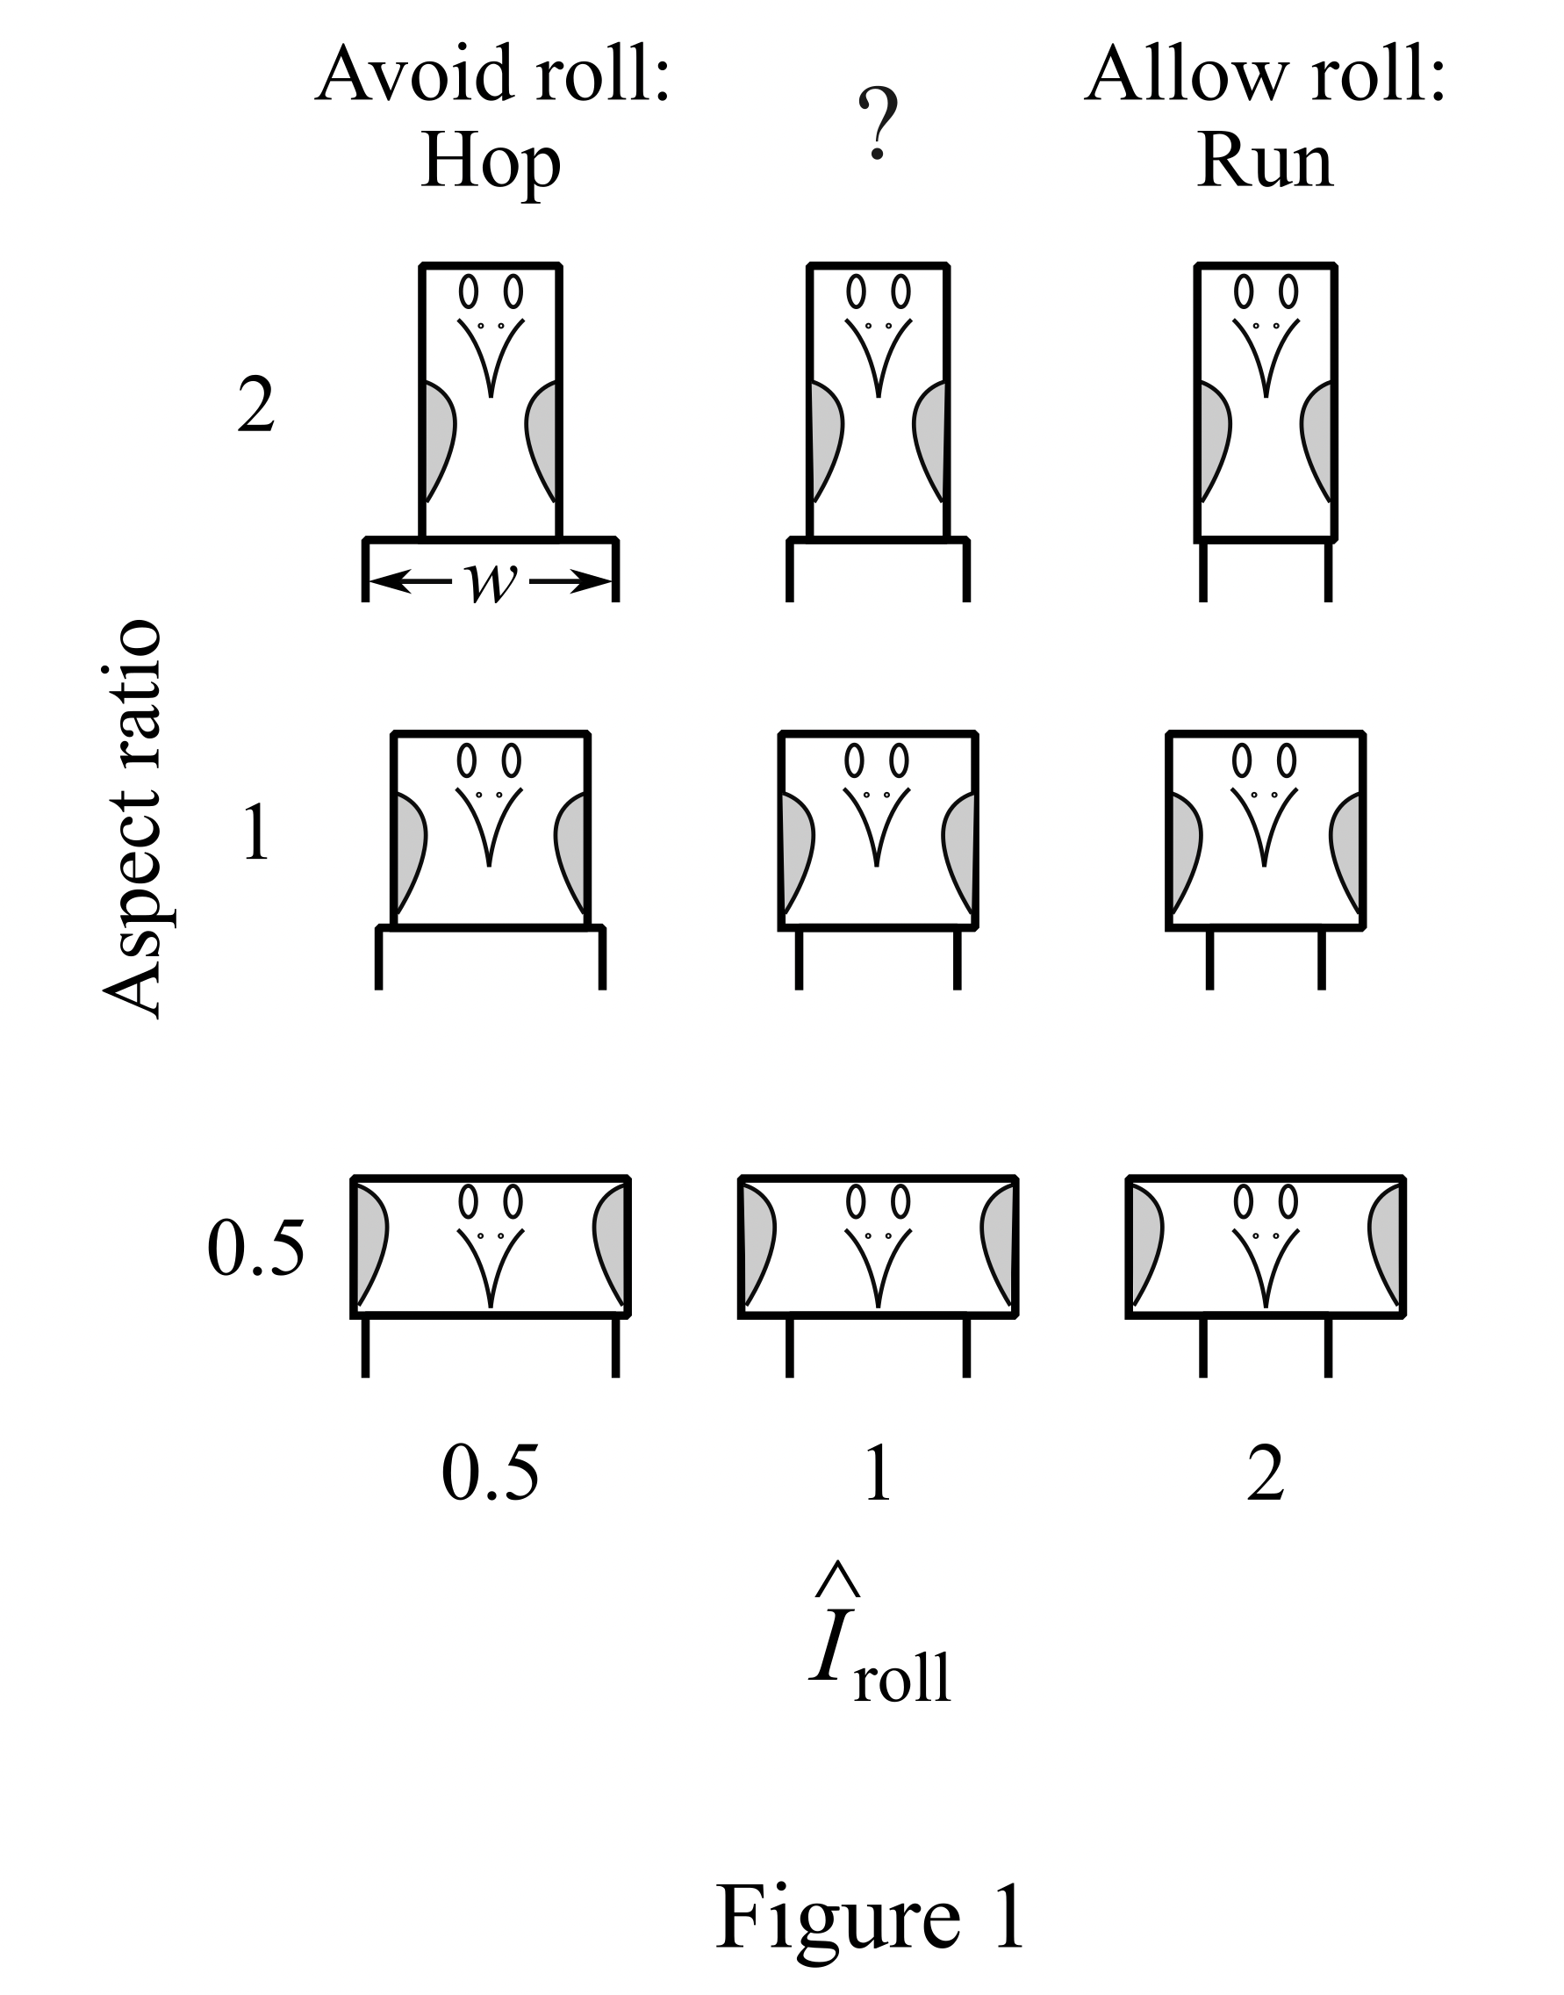

Figure 1
Idealised biped shapes of constant area across a range of aspect ratio and ${\hat{I}}_{roll}$. Aspect ratios of 2 and ½ have the same I, and so same absolute spacing of hips for a given ${\hat{I}}_{roll}$. For the same relative spacing of hips – close to body width – the squat AR=0.5, ${\hat{I}}_{roll}$ = 0.5 should hop in order to avoid high costs of roll; the upright AR=2, ${\hat{I}}_{roll}$= 2 should run to double the contacts per stride and halve the centre of mass work, as the roll costs are relatively low.

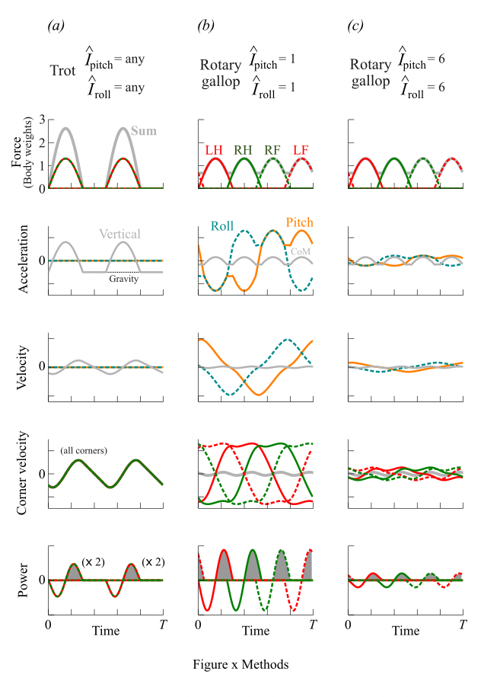

Figure 2.
Graphical representation of the process of calculating positive mechanical work (grey shaded areas) demand for trot (a), rotary gallop with low moments of inertia (b) and rotary gallop with high moments of inertia (c) at a duty factor of 0.3. Trot imposes no angular accelerations, but results in high fluctuations in centre of mass velocity. Rotary gallop with low moments of inertia result in low centre of mass CoM accelerations and velocities, but high angular accelerations and velocities, resulting in high velocity of each corner when loaded, and so high mechanical power demands; trotting would have been favoured. With high moments of inertia, the low centre of mass accelerations and velocities, and reduced angular accelerations and velocities, result in low corner velocities and so low power demands; a rotary gallop would be favoured.

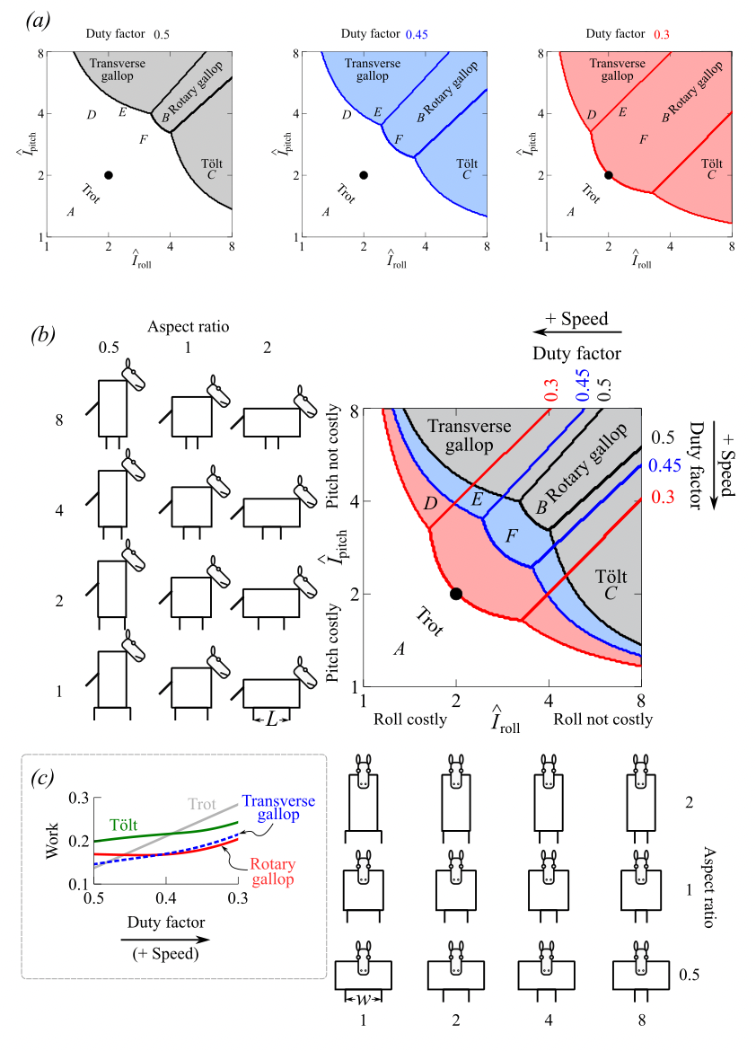

Figure 3.
Energetically favourable gaits as functions of non-dimensional moments of inertia ${\hat{I}}_{\text{roll}}$, ${\hat{I}}_{\text{pitch}}$ across three duty factors relating to slow, medium and fast speeds (a), and amalgamated plots with side-view and front-view cartoons for the range of ${\hat{I}}_{roll}$ and ${\hat{I}}_{pitch}$ and aspect ratios (b). The black dot at ${\hat{I}}_{\text{roll}}=2$, ${\hat{I}}_{\text{pitch}}=2$ indicates the predicted trot-rotary gallop transition at very low duty factor. Capital letters denote $\hat{I}$ coordinates suitable for: A: common hippopotamus, reported to trot but not gallop; B: giraffe, reported to favour rotary gallop and never trot; C: elephant, that tolt (running walk) but have never been observed trotting or galloping; D; horse, that usually transition from trot to transverse gallop but not to rotary gallop with increasing speed; E: dog, that transitions on to a rotary gallop at high speeds; and F, that transitions from trot to rotary gallop without the transverse gallop intermediate. The work demand for all 4 gaits at coordinate E (inset, (c); at ${\hat{I}}_{roll}=2.5$, ${\hat{I}}_{pitch}$=4), normalised by the centre of mass cost of hopping (so trot would approach 0.5 as duty factor becomes very small)) shows the transition in favoured gait from trot, through transverse gallop, to rotary gallop with decreasing duty factor (increasing speed). Note that the difference between transverse and rotary gallop costs is relatively small.

References (to be culled)

Alexander, R. McN. (1976). Mechanics of bipedal locomotion. In Perspectives in
Experimental Biology, Vol. 1 (ed. P. Spencer-Davies), pp. 493-504. Oxford:
Pergamon Press.

Alexander, R. McN. (1977). Mechanics and scaling of terrestrial locomotion. In Scale effects in animal locomotion (ed. T. J. Pedley), pp. 93–110. New York: Academic Press.

Alexander, R. McN. (1984). The gaits of bipedal and quadrupedal animals. The International Journal of Robotics Research, 3(2), 49-59.

Alexander, R. McN. (1988). Why mammals gallop. American zoologist, 28(1), 237-245.

Alexander, R. McN. (1989). Optimization and gaits in the locomotion of vertebrates. Physiological reviews, 69(4), 1199-1227.

Aristotle 350BCE. On the gait of animals. (Transl. by ASL Farquharson). See, for example, https://ebooks.adelaide.edu.au/a/aristotle/gait/.

Bertram, J. E., & Gutmann, A. (2009). Motions of the running horse and cheetah revisited: fundamental mechanics of the transverse and rotary gallop. Journal of the Royal Society Interface, 6(35), 549-559.

Biancardi, C. M., & Minetti, A. E. (2012). Biomechanical determinants of transverse and rotary gallop in cursorial mammals. Journal of Experimental Biology, 215(23), 4144-4156.

Blickhan, R. (1989). The spring-mass model for running and hopping. Journal of biomechanics, 22(11-12), 1217-1227.

Carrier, D. R., Walter, R. M., & Lee, D. V. (2001). Influence of rotational inertia on turning performance of theropod dinosaurs: clues from humans with increased rotational inertia. Journal of Experimental Biology, 204(22), 3917-3926.

Caro, T. M. (1986). The functions of stotting in Thomson's gazelles: some tests of the predictions. Animal Behaviour, 34(3), 663-684.

Cartmill, M., Lemelin, P., & Schmitt, D. (2002). Support polygons and symmetrical gaits in mammals. Zoological Journal of the Linnean Society, 136(3), 401-420.

Dunbar, D. C., Badam, G. L., Hallgrímsson, B., & Vieilledent, S. (2004). Stabilization and mobility of the head and trunk in wild monkeys during terrestrial and flat-surface walks and gallops. Journal of Experimental Biology, 207(6), 1027-1042.

Farley, C. T., & Taylor, C. R. (1991). A mechanical trigger for the trot-gallop transition in horses. Science, 253(5017), 306-308.

Fedak, M. A., Heglund, N. C., & Taylor, C. R. (1982). Energetics and mechanics of terrestrial locomotion. II. Kinetic energy changes of the limbs and body as a function of speed and body size in birds and mammals. Journal of Experimental Biology, 97(1), 23-40.

Geyer, H., Seyfarth, A., & Blickhan, R. (2006). Compliant leg behaviour explains basic dynamics of walking and running. Proceedings of the Royal Society B: Biological Sciences, 273(1603), 2861-2867.

Gray, J. (1944). Studies in the mechanics of the tetrapod skeleton. Journal of experimental biology, 20(2), 88-116.

Hildebrand, M. (1961). Further studies on locomotion of the cheetah. Journal of mammalogy, 84-91.

Hildebrand, M. (1965). Symmetrical Gaits of Horses: Gaits can be expressed numerically and analyzed graphically to reveal their nature and relationships. Science, 150(3697), 701-708.

Hildebrand, M. (1989). The quadrupedal gaits of vertebrates. Bioscience, 39(11), 766.

Hildebrand, M., & Hurley, J. P. (1985). Energy of the oscillating legs of a fast‐moving cheetah, pronghorn, jackrabbit, and elephant. Journal of morphology, 184(1), 23-31.

Hoyt, D. F., & Taylor, C. R. (1981). Gait and the energetics of locomotion in horses. Nature, 292(5820), 239-240.

Hoyt, D. F., Wickler, S. J., Dutto, D. J., Catterfeld, G. E., & Johnsen, D. (2006). What are the relations between mechanics, gait parameters, and energetics in terrestrial locomotion?. Journal of Experimental Zoology Part A: Comparative Experimental Biology, 305(11), 912-922.

Hudson, P. E., Corr, S. A., & Wilson, A. M. (2012). High speed galloping in the cheetah (Acinonyx jubatus) and the racing greyhound (Canis familiaris): spatio-temporal and kinetic characteristics. Journal of Experimental Biology, 215(14), 2425-2434.

Hutchinson, J. R., & Pringle, E. V. (2024). Footfall patterns and stride parameters of common hippopotamus (Hippopotamus amphibius) on land. PeerJ, 12, e17675.

Hutchinson, J. R., Schwerda, D., Famini, D. J., Dale, R. H., Fischer, M. S., & Kram, R. (2006). The locomotor kinematics of Asian and African elephants: changes with speed and size. Journal of Experimental Biology, 209(19), 3812-3827.

Jayes, A. S., & Alexander, R. McN. (1978). Mechanics of locomotion of dogs (Canis familiaris) and sheep (Ovis aries). Journal of zoology, 185(3), 289-308.

Jayes, A. S., & Alexander, R. McN. (1980). The gaits of chelonians: walking techniques for very low speeds. Journal of Zoology, 191(3), 353-378.

Kram, R., & Taylor, C. R. (1990). Energetics of running: a new perspective. Nature, 346(6281), 265-267.

Lee, D. V., Bertram, J. E., Anttonen, J. T., Ros, I. G., Harris, S. L., & Biewener, A. A. (2011). A collisional perspective on quadrupedal gait dynamics. Journal of the Royal Society Interface, 8(63), 1480-1486.

Lee, D. V., & Biewener, A. A. (2011). BigDog-inspired studies in the locomotion of goats and dogs.

McGhee, R. B., & Frank, A. A. (1968). On the stability properties of quadruped creeping gaits. Mathematical Biosciences, 3, 331-351.

McClearn, D. (1992). Locomotion, posture, and feeding behavior of kinkajous, coatis, and raccoons. Journal of Mammalogy, 73(2), 245-261.

McGhee, R. B., & Frank, A. A. (1968). On the stability properties of quadruped creeping gaits. Mathematical Biosciences, 3, 331-351.

McMahon, T. A. (1985). The role of compliance in mammalian running gaits. Journal of experimental biology, 115(1), 263-282.

Marey, É. J. (1873). La machine animale: locomotion terrestre et aérienne (Vol. 3). G. Baillière.

Murphy, K. N., & Raibert, M. H. (1984). Trotting and bounding in a simple planar model. Pittsburgh: Carnegie-Mellon University.

Murphy, K.N. (1984). Trotting and Bounding in a Simple Planar Model. PhD thesis, Carnegie-Mellon University, Pittsburgh, PA, USA.

Muybridge, E. (1957). Animals in motion. New York: Dover Publications Inc.

Pennycuick, C. J. (1976). On the running of the gnu (Connochaetes taurinus) and other animals. Journal of Experimental Biology, 63(3), 775-799.

Polet, D. T. (2021). The Murphy number: how pitch moment of inertia dictates quadrupedal walking and running energetics. Journal of Experimental Biology, 224(5), jeb228296.

Rashevsky, N. (1948). On the locomotion of mammals. The Bulletin of mathematical biophysics, 10(1), 11-23.

Robilliard, J. J., Pfau, T., & Wilson, A. M. (2007). Gait characterisation and classification in horses. Journal of Experimental Biology, 210(2), 187-197.

Ruina, A., Bertram, J. E., & Srinivasan, M. (2005). A collisional model of the energetic cost of support work qualitatively explains leg sequencing in walking and galloping, pseudo-elastic leg behavior in running and the walk-to-run transition. Journal of theoretical biology, 237(2), 170-192.

Self Davies, Z. T., Spence, A. J., & Wilson, A. M. (2019). Ground reaction forces of overground galloping in ridden Thoroughbred racehorses. Journal of Experimental Biology, 222(16), jeb204107.

Schmitt, D., Cartmill, M., Griffin, T. M., Hanna, J. B., & Lemelin, P. (2006). Adaptive value of ambling gaits in primates and other mammals. Journal of Experimental Biology, 209(11), 2042-2049.

Shine, C. L., Penberthy, S., Robbins, C. T., Nelson, O. L., & McGowan, C. P. (2015). Grizzly bear (Ursus arctos horribilis) locomotion: gaits and ground reaction forces. Journal of experimental Biology, 218(19), 3102-3109.

Srinivasan, M., & Ruina, A. (2006). Computer optimization of a minimal biped model discovers walking and running. Nature, 439(7072), 72-75.

Usherwood, J. R. (2005). Why not walk faster?. Biology letters, 1(3), 338-341.

Usherwood, J. R., & Self Davies, Z. T. (2017). Work minimization accounts for footfall phasing in slow quadrupedal gaits. Elife, 6, e29495.

Usherwood, J. R. (2020a). An extension to the collisional model of the energetic cost of support qualitatively explains trotting and the trot–canter transition. Journal of Experimental Zoology Part A: Ecological and Integrative Physiology, 333(1), 9-19.

Usherwood, J. R. (2020b). The possibility of zero limb-work gaits in sprawled and parasagittal quadrupeds: insights from linkages of the industrial revolution. Integrative Organismal Biology, 2(1), obaa017.

Usherwood, J. R. (2022). Legs as linkages: an alternative paradigm for the role of tendons and isometric muscles in facilitating economical gait. Journal of Experimental Biology, 225(Suppl_1), jeb243254.

Usherwood, J. R. (2024). The functions of leg muscles, structures and mechanisms in running. Biology Letters, 20(8).

Usherwood, J. R., & Granatosky, M. C. (2020). Limb work and joint work minimization reveal an energetic benefit to the elbows-back, knees-forward limb design in parasagittal quadrupeds. Proceedings of the Royal Society B: Biological Sciences, 287(1940).

Usherwood, J. R., & Self Davies, Z. T. (2017). Work minimization accounts for footfall phasing in slow quadrupedal gaits. Elife, 6, e29495.

Usherwood, J. R., & Smith, B. J. (2018). The grazing gait, and implications of toppling table geometry for primate footfall sequences. Biology Letters, 14(5).

van Bijlert, P. A., Geijtenbeek, T., Smit, I. H., Schulp, A. S., & Bates, K. T. (2024). Muscle-driven predictive physics simulations of quadrupedal locomotion in the horse. Integrative and comparative biology, 64(3), 694-714.

Van De Graaff, K. M., Harper, J., & Goslow Jr, G. E. (1982). Analysis of posture and gait selection during locomotion in the striped skunk (Mephitis mephitis). Journal of Mammalogy, 63(4), 582-590.

Waldron, K. J., Estremera, J., Csonka, P. J., & Singh, S. P. N. (2009). Analyzing bounding and galloping using simple models.

White, T. D. (1990). Gait selection in the brush-tail possum (Trichosurus vulpecula), the northern quoll (Dasyurus hallucatus), and the Virginia opossum (Didelphis virginiana). Journal of Mammalogy, 71(1), 79-84.

Willey, J. S., Biknevicius, A. R., Reilly, S. M., & Earls, K. D. (2004). The tale of the tail: limb function and locomotor mechanics in Alligator mississippiensis. Journal of experimental biology, 207(3), 553-563.

Williams, S. B., Tan, H., Usherwood, J. R., & Wilson, A. M. (2009). Pitch then power: limitations to acceleration in quadrupeds. Biology letters, 5(5), 610-613.

Wilson, A. M., Watson, J. C., & Lichtwark, G. A. (2003). A catapult action for rapid limb protraction. Nature, 421(6918), 35-36.

Witte, T. H., Hirst, C. V., & Wilson, A. M. (2006). Effect of speed on stride parameters in racehorses at gallop in field conditions. Journal of Experimental Biology, 209(21), 4389-4397.

 |  | Biped |  | Quadruped
 | Figure 3 symbols | Hop | Run | Trot | Tolt | Transverse gallop | Rotary gallop
Foot contact sequence |  | [HL, FR]- | HL-FR- | [HL,FR]-[HR,FL]- | HL-FL-HR-FR- | HL-HR-FL-FR- | HL-HR-FR-FL-
Example species
Kangaroo | x | Yes | No | x | x | x | x
Ostrich | x | No | Yes | x | x | x | x
Common Hippopotamus | (A) | x | x | Yes | No | No | No
Giraffe | (B) | x | x | No | No | No* | Yes
Elephant | (C) | x | x | No | Yes | No | No
Horse | (D) | x | x | Slow | No* | Fast | No*
Dog | (E) | x | x | Slow | No | Medium | Fast
Cheetah | (F) | x | x | Slow | No | No* | Fast
Table 1 legend. Summary of bipedal and fast quadrupedal gaits and their distribution across example species and speeds (H indicates hind, F fore, R right and L left). In each case the foot contact sequence is assumed to begin with the Hind Left (HL); equivalent gaits with a different lead begin with HR, swapping the L and R throughout. Square brackets (the hop, trot) indicate simultaneous foot contacts. Asterisks indicate ‘soft’ no: most species that can gallop use occasional strides of their less favoured form of gallop; and some horse breeds can also tolt.

 |  | Biped |  | Quadruped
Terms | Symbols or normalisation | Hop | Run | Trot | Transverse gallop | Tolt | Rotary gallop
Number of vertical impulses each stride | N_{CoM} | 1 | 2 | 2 | 4 | 4 | 4
Number of rotational impulses each stride | N_{rot} | 0 | 2 (L, R) | 0 | 4 (L, R, L, R) | 4 (H, F, H, F) | 4 (HL, HR, FR, FL)
Rotational moment arm | r | N/A | w/2 | N/A | w/2 | L/2 | If w=L, $\frac{L}{\sqrt{2}}$
Moment of inertia | I | N/A | I_{roll} | N/A | I_{roll} (I_{pitch} $≈∞)$ | I_{pitch} (I_{roll} $≈∞)$ | I_{diag} = I_{roll =} I_{pitch}
Sum work demand on CoM | $$\frac{\sum{W_{\text{CoM}}^{+}}}{{mg^{2}T^{2}}/8}$$ | 1 | ½ | ½ | ¼ | ¼ | ¼
Sum rotational work demand | $$\frac{\sum{W_{\text{rot}}^{+}}}{{mg^{2}T^{2}}/{16\hat{I}}}$$ | 0 | 1 | 0 | ½ | ½ | 1
Conditions for energetic advantage |  | $${\hat{I}}_{\text{roll}}<1$$ | $${\hat{I}}_{\text{roll}}>1$$ | $$\hat{I}<1$$ | ${\hat{I}}_{\text{roll}}>1$ and ${\hat{I}}_{\text{pitch}}≈∞$ | ${\hat{I}}_{\text{pitch}}>1$ and ${\hat{I}}_{\text{roll}}≈∞$ | $${\hat{I}}_{\text{pitch}}≈{\hat{I}}_{\text{roll}}>2$$

Table 2. Summary of terms required and results for each gait for the impulsive work demand model (Section 2.1).

 | Biped |  | Quadruped
Conditions | Hop | Stride | Walk | (Slow) Trot | (Slow) Bound | 4-beats (tolt, gallops)
Duty factor $β$ | x | $$β≥\frac{1}{2}$$ | $$β≥\frac{3}{4}$$ | $$β≥\frac{1}{2}$$ | $$β≥\frac{1}{2}$$ | $$β≥\frac{1}{4}$$
$${\hat{I}}_{\text{roll}}$$ | x | $${\hat{I}}_{\text{roll}}=∞$$ | ${\hat{I}}_{\text{roll}}=\text{any}$ | ${\hat{I}}_{\text{roll}}=∞$ or L_{step}=L_{foot} | $${\hat{I}}_{\text{roll}}=\text{any}$$ | $${\hat{I}}_{\text{roll}}=∞$$
$${\hat{I}}_{\text{pitch}}$$ | x | $${\hat{I}}_{\text{pitch}}=∞$$ | $${\hat{I}}_{\text{pitch}}=\text{any}$$ | $${\hat{I}}_{\text{pitch}}=\text{any}$$ | $${\hat{I}}_{\text{pitch}}=∞$$ | $${\hat{I}}_{\text{pitch}}=∞$$
Idealised example | x | Jacana | Tortoise | Alligator | None? | Fast horse, cheetah, elephant

Table 3. Summary of conditions allowing theoretical zero mechanical work demand given ideal vertical ground reaction force profiles.

