Introduction

Last week, you took frame numbers from videos and made calculations to describe various gaits.

This week, we will look at DUTY FACTOR, explain why it changes with speed, and use it to estimate the forces on a tendon.

The terms in the Glossary from week 1 will be used here, often without re-explanation. Have the list to hand.

Consider this question: why is a greyhound much more likely to be injured when galloping at high speed than when standing still?

Discuss this question with a friend, and think up an answer… briefly note it here:

Now consider that the vertical forces on a wheel would not depend on speed or incline. Is this consistent with your answer about the greyhound?

Choose someone in your group.
Estimate the length of their extended leg. (A 1.9m man has a length of 1.0m). Write your answer here:

(1)

If we say that walking cannot have an aerial phase, what is the maximum possible step length of your volunteer?

(2)

Draw a sketch of your subject taking the longest possible walking step here:

(3)

Try it out (carefully). Approximately how many leg lengths can they actually manage in 1 stride (2 steps)? Write your answer here:

(4)

You may find that the longest walking step achievable by your subject is less than your theoretical maximum. This does not matter today (though it is interesting – see Usherwood, 2005).

Next comes the important difference between legs (and wings) and wheels (and propellers): they must ‘reciprocate’ and swing back again for the next stance (or downstroke). A normal step is about 2.5 foot lengths. Time (use a phone) your volunteer swinging their legs to move their feet backwards and forwards about 2.5 feet, as fast as they can (carefully) 10 times. Write the time (in seconds) taken for the 10 full (backwards and forwards) cycles here:

(5)

What would the time have been for 1 full cycle (divide by 10)? (s).

(6)

Express this as a frequency (1/s).

(7)

Remembering there are two steps to one stride, calculate your maximum theoretical walking speed (the calculation would be 2x(answer to (2)) for stride length, times (answer to (7)) for stride frequency):

(8)
(and can you give the right units?)

This calculated top walking speed is likely to be much faster than is realistic (we do know why), but it does give one limit to locomoting with a duty factor of 0.5: step length can’t be more than double leg length; legs can’t be swung backwards and forwards at infinite frequency.

Consider the leg swinging with a mass load. Obviously, if the mass was on the foot it would have a much bigger effect on the maximum frequency. Briefly explain why fast animals tend to have very low-mass distal limbs. You may use the term ‘rotational inertia’ (see Glossary).

(9)

Now consider what would happen at higher speeds. Sketch a cartoon of one complete stride of:

Walking at maximum speed with maximum stance length.

(10)

Running at twice that speed with the same stance length and stride frequency.

(11)

What must have happened to the Duty Factor?

(12)

This leads to a take-home message:
Duty factor goes down with increasing speed because stance length is constrained (can’t exceed the splits) and step frequency is constrained (waggling legs backwards and forwards takes time and effort).

So what? Now on to estimating leg forces.

Consider a 4-legged table of mass m=20kg.
What is its weight W (remember the Glossary from week 1).

(13)

If the weight was supported by each leg equally, what is vertical force F acting on one of the legs?

(14)

If the table jumped up and down, spending half of the time in the air, and half of the time with all the feet on the ground (a duty factor DF of 0.5), what would the average vertical force be on one leg when it is in contact with the ground (it is zero when it is in the air)?
(Remember that the average vertical force – including the time on ground and in the air – must be enough to support weight W)

(15)

If the table jumped differently, with a DF of 0.25, what would the average vertical force on one leg when in contact with ground be now?

(16)

Given this development, have a go at writing an equation for vertical force F using the terms above. Do not worry if you end up skipping this.

(17)

But it does give a second take-home message: vertical forces supported by legs are higher when the duty factor is lower, because the average vertical force must support body weight, and any time spent not on the ground is spent not supporting body weight.

Now on to estimating muscle and tendon forces.
Take a volunteer. Estimate their weight (this need not be accurate or truthful). Get them to stand on one foot. What is the vertical force acting along the one leg?

(18)

Now ask the volunteer to gently lift the heel and stand as steadily as possible on one leg on tip-toe (ball-of-foot). What is the vertical force F acting along the leg now?

(19)

Measure (or, if you don’t have a ruler to hand, estimate) the ‘external moment arm’ R and the muscle (and tendon) moment arm r.

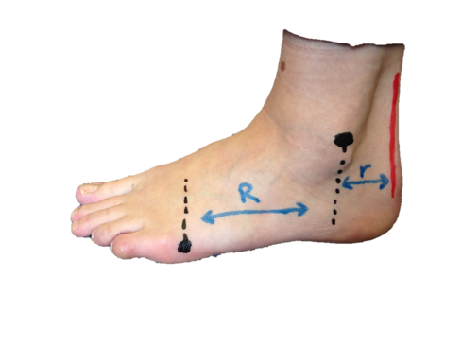
Write your measurements or estimates here:

(20).

Think: if the external moment arm R was bigger, would the Achilles tendon force be bigger or smaller?

Use your answer to (19) and (20) to estimate the tension force T experienced by the Achilles tendon behind the ankle. (T=F x R/r).

(21)

Final take-home: to get to muscle and tendon forces from leg forces (which can be estimated using Duty Factor), you need to know the ratio between external and muscle moment arms (R/r).

Classic reference
Alexander, R.McN., Maloiy, G.M.O., Barbara Hunder, Jayes, A.S. and Nturibi, J. (1979). Mechanical stresses in fast locomotion of buffalo (Syncerus caffer) and elephant (Loxodonta africana). J. Zool. Lond. 189, 135-144.

