Introduction
What is a gait? The best I can come up with is:
‘Something characteristic about how an animal moves as it locomotes’.
The dictionary definition usually mentions walking and running, and perhaps the walk-trot-gallop of dogs and horses. But it is much broader than that: it can cover swimming fish, flapping birds, crawling millipedes, and diseased animals including humans. It can focus on motions of the whole body, or of the joints; it can focus on forces or fluctuations in energy.

‘What is a gait?’, ‘How is it described?’ and ‘What are the implications?’ are questions that have been asked at least since Aristotle over 2000 years ago. Despite all this time, and considerable work by the members of the Structure and Motion lab at the RVC, we still can’t answer many of them. Here is a short list, some of them mostly answered, some of them definitely not:

Why can a human walk slowly, run fast, run slowly… but NOT walk fast?
Would a Tyrannosaurus rex run?
What gaits can/do 3-legged dogs use?
Why do mosquitoes whine but butterflies flutter?
Why do children with autism run in a distinctive manner?
Why do blue tits flap-bound, geese flap, and hawks flap-glide?
Why does a toddler or small bird not have an aerial phase when running?
Why does a magpie walk, skip and jump?
Why do some frogs hop but others walk or even ‘run’?
Why are the fastest running animals neither the smallest nor the largest?
How fast do cheetahs actually run when hunting?
What variations in gait are ‘idiopathic’ (a difference from normal without consequence), and what ‘pathological’ (a bad thing)?

Why does a rhino go from walk to trot to canter to gallop with increasing speed, but:
A giraffe never trots;
A common hippopotamus never gallops;
An elephant never trots or gallops?

The two ‘gait’ DLs will cover:
1) how to describe legged gaits, specifically their foot contact timings;
2) some of why these timings change with speed, and why vertical forces, bone and tendon forces increase with speed.

Glossary
You will need to become familiar with the following terms and how they are calculated.

Speed (m/s; other units include kph, mph)
The rate of change of distance.

Velocity (m/s)
The rate of change of displacement. So the same as speed, but with direction. (Up and forward is normally positive, down or backwards negative, but this is just convention).

Acceleration (m/s²)
The rate of change of velocity.

Mass (kg)
A measure of ‘inertia’, or ‘resistance to acceleration’.

Remember Newton: F=ma

Gravity (m/s²; sometimes given as g)
The acceleration due to gravity. Usually given as a negative to indicate downward, often approximated as -9.81 m/s² or rounded to -10m/s². Also known as gravitational field strength with units N/kg.

Weight (newtons, N)
The force due to body mass and gravity. Be very careful with this term. It is common practice (though strictly wrong) to give the weight in terms of its mass (grammes, kg, tonnes etc.). This generally doesn’t matter too much as we are normally on the surface of the earth (gravity is approximately constant).

Using Newton again: W=mg

Stance time (s)
The duration a foot is in contact with the ground

Stride time or stride period (s)
The duration for a complete cycle of foot contacts. Often calculated from the time between on foot contacting the ground and the same foot contacting the ground again.

Step time or stride period (s)
The duration for one half-stride for a symmetrical gait. For instance, from left foot on to right foot on in human walking or running. Be careful: some older, and particularly human, literature have different conventions for what a ‘step’ and a ‘stride’ is. The idea of a ‘step’ does not work for asymmetric gaits (skipping, galloping etc.)

Frequency (1/s or hertz Hz)
The rate of a cyclic event – how many times per second. Stride and step periods are often expressed their inverses – frequencies.

Swing time or protraction period (s)
The length of time taken for a limb to be swung from the end of one contact period to the next.

Aerial time (s)
The length of time no legs are in contact with the ground.

Stance length (m)
The distance travelled when one foot is in contact with the ground (stance time).

Rotational inertia (kg m²)
Resistance to angular acceleration. Like mass for acceleration, but how the mass is distributed matters. Important for week 2.

Duty factor (dimensionless: a fraction, so can be expressed as fraction, decimal or %)
The proportion of a stride that a given foot is in contact with the ground. Really useful when describing gaits (‘walk’ can be DF>0.5 and ‘run’ DF<0.5). Very important for estimating forces (week 2).

DF=Tstance/(Tstride)

Or given that

Tstride=Tstance+Tswing

DF=Tstance/(Tstance+Tswing)

Phase (dimensionless: can be a fraction, percentage or angle)
The proportion of a cycle something happens.
Here, we will use a hind foot contact (if there is an obvious ‘first’ hind foot, use that one) to define the clocking cycle. This is not the only convention that works.

Ipsilateral: same side

Contralateral: other side

When describing a gait:

Is the duty factor above 0.5 (walk) or below 0.5 (not a walk)

Is the phase of the contralateral foot about 50%? If so, it is a ‘symmetrical gait’ (walk, run, trot, pace). If not it is an ‘asymmetrical gait’.

Symmetrical gaits
Is the phase of the ipsilateral forefoot about 50%? Then it is a trotting pattern.
Is the phase of the ipsilateral forefoot about 0/100% (so contralateral 50%)? Then it is a pacing footfall pattern.

Walking hind-fore phasing very varied. But some phases never observed.

Is there an aerial phase? A ‘running walk’ has a duty factor below 0.5 but no aerial phase. This is seen in fast elephants and Icelandic ponies.

Asymmetrical gaits
What is the footfall pattern?
Does it go round in a circle? If so, it is ‘rotary’.
Does it go diagonal-diagonal? If so, it is ‘transverse’.

Is there an ‘extended’ aerial phase? (Think of a frog hop).

Is there a ‘gathered’ aerial phase (legs ‘gathered’ underneath body – typical of galloping horse).

Are there both aerial phases?
Or neither?

How many frames in a stride (hind on to same hind on)?
How many frames in a stance (hind on to hind off)?
How many frames in a swing (hind off to hind on)?
How many frames from hind on to contralateral hind on?
How many frames in gathered aerial phase?
How many frames in extended aerial phase?
What is the sequence of foot contacts?

Using these, decide: What is the gait and how can it be described?
Bipedal/quadrupedal/(hexapedal…)
Walk?
Symmetric: Run, trot, pace, running walk
Asymmetric: canter (3-beat), gallop (4-beat), rotary or transverse?
What is the duty factor?
Do you think the gait is fast or slow? Why?

What you need to do.
Find (it may be easier to use your phone):

https://jimusherwoodresearch.com/moving-animal-movies/

See the upcoming Example sheet (Alfie 1). There will be a page prepared for each movie below. You may use the Excel template on the webpage, or you may make your own. For each movie

Measure:
A: Hind 1 on
B: Hind 1 off
C: Hind 2 on
(hind off)
D: Ipsilateral (to Hind 1) fore on
(Ipsilateral off)
(Contralateral fore on)
(Contralateral fore off)
E: Hind 1 on again

And work out using this table. You may use the Template. You will have to choose a sensible ‘Frames per box’ (yellow) for calculating your gait diagram.
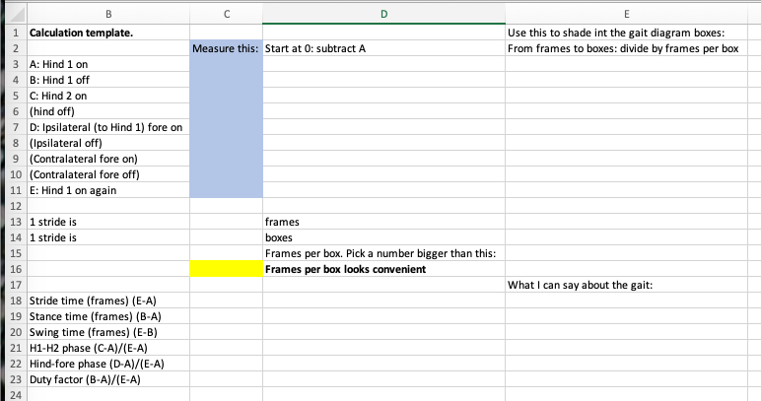

Calculate:
Calculate:
Stride time (E-A)
Stance time (B-A)
Swing time (E-B)
H1-H2 phase (C-A)/(E-A)
Hind-fore phase (D-A)/(E-A)
Duty factor (B-A)/(E-A)

Fill in a ‘gait diagram’, shading squares showing when each foot is on the ground.
Say how many frames each box represents. (Make it convenient). (The grid is 4x40).

Answer:

Is the gait symmetric or asymmetric?

For the asymmetric gaits, are there aerial phases? Are they extended and/or gathered? Is the foot sequencing rotary or transverse.

Would you view the gait as ‘fast’? Why?

What do you think the gait is called? Why? (There may be more than one right answer – remember that ‘gait’ does not have a strict, single definition).

And repeat:
What is the duty factor? (check that it is between 0 and 1).

Example: Alfie 1

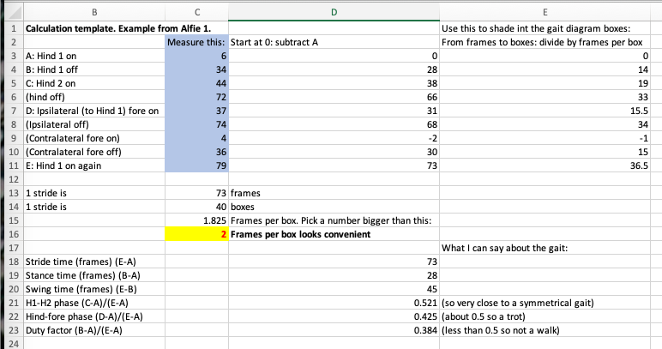

Answer:

Is the gait symmetric or asymmetric?
I think this is a symmetric gait because the H1-H2 phase is close to 0.5

For the asymmetric gaits, are there aerial phases? Are they extended and/or gathered? Is the foot sequencing rotary or transverse.
Not applicable: not an asymmetric gait

Would you view the gait as ‘fast’? Why?
I would think this was a fairly fast gait: duty factor <0.5, there is an aerial phase, and I know that many mammals go walk-trot-canter gallop

What do you think the gait is called? Why?
I think this is a trot: left/right symmetrical, ipsilateral fore about 0.5 phase, duty factor less than 0.5

And repeat:
What is the duty factor? (check that it is between 0 and 1).
0.384

Movie 1: Zombie girl

Answer:

Is the gait symmetric or asymmetric?

For the asymmetric gaits, are there aerial phases? Are they extended and/or gathered? Is the foot sequencing rotary or transverse.

Would you view the gait as ‘fast’? Why?

What do you think the gait is called? Why?

And repeat:
What is the duty factor? (check that it is between 0 and 1).

Movie 2: Ostrich

Answer:

Is the gait symmetric or asymmetric?

For the asymmetric gaits, are there aerial phases? Are they extended and/or gathered? Is the foot sequencing rotary or transverse.

Would you view the gait as ‘fast’? Why?

What do you think the gait is called? Why?

And repeat:
What is the duty factor? (check that it is between 0 and 1).

Movie 3: Horse

Answer:

Is the gait symmetric or asymmetric?

For the asymmetric gaits, are there aerial phases? Are they extended and/or gathered? Is the foot sequencing rotary or transverse.

Would you view the gait as ‘fast’? Why?

What do you think the gait is called? Why?

And repeat:
What is the duty factor? (check that it is between 0 and 1).

Movie 4: Alfie 1 (this should be close to the example)

Answer:

Is the gait symmetric or asymmetric?

For the asymmetric gaits, are there aerial phases? Are they extended and/or gathered? Is the foot sequencing rotary or transverse.

Would you view the gait as ‘fast’? Why?

What do you think the gait is called? Why?

And repeat:
What is the duty factor? (check that it is between 0 and 1).

Movie 5: Aflie 2

Answer:

Is the gait symmetric or asymmetric?

For the asymmetric gaits, are there aerial phases? Are they extended and/or gathered? Is the foot sequencing rotary or transverse.

Would you view the gait as ‘fast’? Why?

What do you think the gait is called? Why?

And repeat:
What is the duty factor? (check that it is between 0 and 1).

Movie 6: Alfie 3

Answer:

Is the gait symmetric or asymmetric?

For the asymmetric gaits, are there aerial phases? Are they extended and/or gathered? Is the foot sequencing rotary or transverse.

Would you view the gait as ‘fast’? Why?

What do you think the gait is called? Why?

And repeat:
What is the duty factor? (check that it is between 0 and 1).

Movie 7: Tsessebe

Answer:

Is the gait symmetric or asymmetric?

For the asymmetric gaits, are there aerial phases? Are they extended and/or gathered? Is the foot sequencing rotary or transverse.

Would you view the gait as ‘fast’? Why?

What do you think the gait is called? Why?

And repeat:
What is the duty factor? (check that it is between 0 and 1).

Movie 8: Giraffe

Answer:

Is the gait symmetric or asymmetric?

For the asymmetric gaits, are there aerial phases? Are they extended and/or gathered? Is the foot sequencing rotary or transverse.

Would you view the gait as ‘fast’? Why?

What do you think the gait is called? Why?

And repeat:
What is the duty factor? (check that it is between 0 and 1).

